DBMS

September Term 2022

Notes

Uriel K Alistair

Contents

Week 1 : Introduction 3

Why DBMS? 3

Levels of abstraction 3

Schema and Instances 4

SQL 4

Database Design 5

Week 2 : Basic SQL 7

Keys 7

Operations of Relational Algebra 8

SQL Syntax 10

Creation 10

Selection 12

Week 3 : Intermediate & Advanced SQL 17

Nested Queries 17

Subqueries in the where clause 17

Subqueries in the from clause 18

Subqueries in the select clause 18

Modifying the Table data 19

Delete 19

Insert 19

Update 19

Modifying the Table Schema 20

Join Expressions 20

Cross join 20

Natural join 21

Making Views 22

Privileges and Roles 23

Formula Sheet 26

Advanced SQL (Functions and Triggers) 28

Week 4 : The ER Model 30

ER diagrams 30

ER to Schema 33

Complex ER Aspects 35

Weeks 5 & 6 : Normalisation (Add MVD math) 37

Functional Dependencies 37

1NF and BCNF 38

Third Normal Form 40

Understanding the Normal Forms 41

Canonical Covers 47

MVD math 49

Week 7 : App Dev with SQL 50

Week 8 : Storing Databases 51

# Week 1 : Introduction

## Why DBMS?

DBMS vs File management system

• Efficiency of files reduces with increasing number of records

• Structural Changes are hard to make in a file based system

• Effort to configure a DBMS from scratch is greater than for a python file system

• Time of queries is extremely less in a DBMS since it is highly optimised for this job.

• A DBMS is much more robust in terms of maintaining logical sanity in the data, maintaining a backup and recovery from a crash with minimum manual intervention

• Easy to give users security-based access in a DBMS

• Programming a python based thing is a pain.

## Levels of abstraction

We think of databases in 3 levels of abstraction - the Physical level, the Logical level and finally, the View level.

The Physical level comprises data structures in which the data is stored and the sequences of 1s and 0s in your physical storage devices that are interpreted. These structures are often highly optimised for rapid information retrieval in a lot of sophisticated ways. We will study about these later. (Week 8)

The Logical level is where we generally work. We plan the attributes out, make relationships between them, put constraints on each etc.

The View level is what the end user sees. Each user may get a different view. This is what is seen in an application.

The Basic idea here is, these are in a sense, separate parts. I can go ahead and change the way in which my data is stored and not impact the logical or view levels in any way. (This is called Physical Data independence)

Changing the Logical level will have a very real physical impact, though; Not just in the trivial sense of having to store more data, but the way in which the data is accessed is optimised according to the logical structures, so more sophisticated changes do occur.

Maybe, think of it this way: Linked Lists of numbers cannot be accessed in log N time because of the way pointers work. Arrays of numbers cannot have log N insertion due to swaps in the consecutive memory spaces. A self-balancing binary search tree is the ideal way to store a list of numbers.

Now, what if you don’t have one row of numbers, but ten rows in a table? That’s a much more complicated problem to tackle. There are trees designed to tackle query speed, and the way the trees are stored changes once in so many *queries* in some implementations. Depending on what you ask frequently, it can change the trees to better serve your needs. What I’m trying to say is, the physical layer is a non-trivial one.

Extending how the physical level doesn’t touch the layers above it, making a change to the logical interconnections in your database must not affect your view level. If you have a website that needs you to pull a particular piece of data and put it in a spot, it doesn’t care what the internal structure of the database is.

Changing the view level can possibly result in demands for the logical level, thus cascading change down to the physical level.

If you like, these are akin to 3 blocks, one on top of another.

## Schema and Instances

When we work with Databases, we think of Schema.

This is the general rule that sets the relations and constraints of the attributes of a database.

We call the actual contents of the entire database, all the table data and stuff, as an instance. It’s one instance of how this database can look, and it looks this way at this instant of time.

## SQL

SQL will be one of the languages we will work extensively with in this course. It’s a highly optimised query language; way more than meets the eye. Even with rather large databases, it can perform complex queries in incredibly short spans of time.

That’s because there are several parts to SQL we aren’t aware of at the moment. We will study what exactly these moving parts are and how they are optimised.

However, despite being so powerful, SQL is not a Turing complete language, meaning it cannot do everything C++ or Python can. That makes sense since logical and arithmetical procedures aren’t what SQL is meant for. It’s for querying databases, and that alone. So, typically, SQL is embedded within another host programming language like C++ or Python.

## Database Design

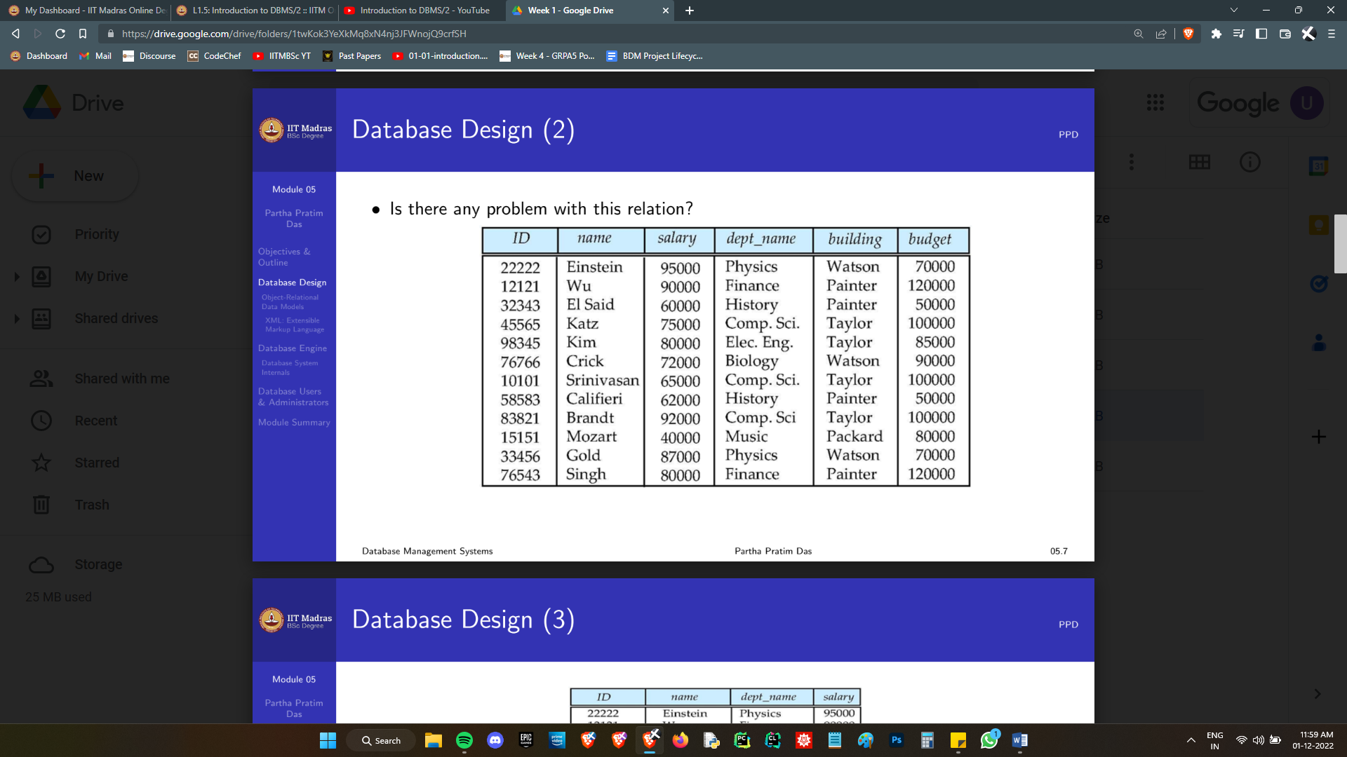

If you notice, the dept_name and budget always match. In fact, the building also matches. Presumably, the budget and building are properties of the dept_name. If that were the case, this would be a very bad way to store this data.

For instance, if the budget of the CS dept. changes, I need to change it in 3 different places. If the changing process is interrupted or if some query changes only one of the three, we get conflicting data.

Let’s say it’s a logical constraint that the CS dept. must have just one budget. When we have redundancies in data, we increase the chances of *anomalies,* especially when you have a database accessed simultaneously at various levels by multiple people. Apart from the possibilities of anomaly, redundancies increase storage requirements, as well as processing load when you need to make an update. It just doesn’t make sense to store it this way.

The ideal way to store this would be to have a separate table containing dept_name budget and building. We need to retain the dept_name of each prof in the table shown though. This is so that we can join the two tables back for any queries that demand it.

This is an example of Schema design. You should not just stick everything in one table and call it a day. Ways to *methodically* test how good your schema design are described by the Normalisation theory. (Week 5)

Before the use of Normalisation theory, we use something known as the Entity Relationship Model (Week 4) to get a concise understanding and visual feel of the Database we are designing. Any normalisation can be done at the ER stage itself, but it relies heavily on intuition. The ER model *really* helps when we begin to handle larger schema, and lets you concretely think about and review your design.

Apart from logical Schema design, we also need to worry about the physical schema design, as I mentioned earlier.

So far, we can see 4 large problem statements looming in sight:

How do I use SQL, and how can I actually make the queries I want? (Weeks 2 and 3)

How do I integrate SQL with some other language and merge it into app development? (Week 7)

How do I make efficient, logical Schema for my databases? (Weeks 4, 5, and 6)

How are databases stored? (Weeks 8 and 9)

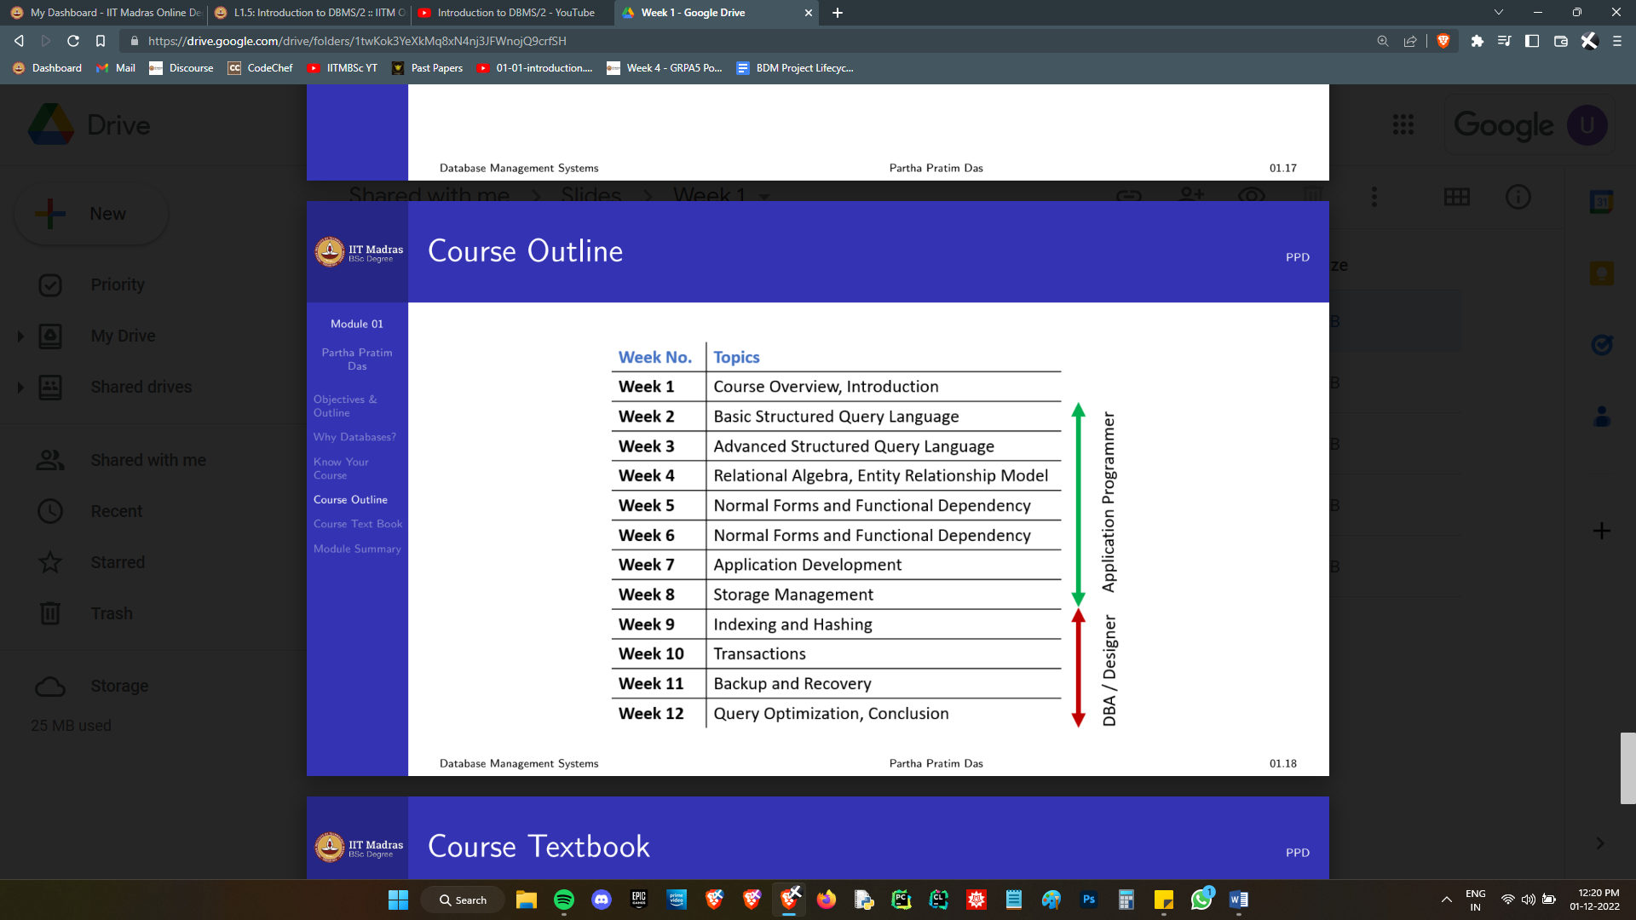Now, here is the overall course structure:

Hopefully, we now have sufficient motivation to proceed. The problems we will deal with in the last 3 weeks are fairly obvious, but the solutions are not obvious. The Roadmap is clear. Let’s walk the road.

# Week 2 : Basic SQL

## Keys

The only constraint there exists on a general relational database, is that no two rows of data are entirely identical. That’s because we deal with this in a set theoretic manner. (**Note:** SQL does allow duplicate rows)

So, it’s a given that if I tell you all the entries, that is, the entire row, you can uniquely identify which row I am talking about.

The question is, can a subset identify the row uniquely?

If a set of attributes can uniquely identify a tuple, it’s called a *superkey*. Super, because it can be a superset of some other key. All attributes together are guaranteed to be a superkey.

If there does not exist any proper subset of a superkey that is also a superkey, in other words, the superkey is *minimal*, then it’s called a candidate key.

(Note: A candidate key need not have a size that is globally minimum. For instance, a single attribute may determine the entire relation, and a set of attributes not containing this, may do the same. In this case, both are candidate keys, since no subset of themselves is a key.)

Note that we cannot just observe data and assume a key; I cannot look at a table of student details and say, “Okay, No two students will have the same roll no, so it’s a primary key”.

No.

What if I add a duplicate roll no?

Do you know if I won’t?

We need to know that kind of thing for sure. Especially when you want to use multiple attributes as your key. It needs to be stated in the definition of the attribute that this will be forcefully maintained to be unique.

The things we need to know are called *functional dependencies.* Does A depend on B and C? Does C determine D and E? Such things. With that information, we can find a set that can determine the rest of the data.

A Foreign Key is a different type of key whose role is to preserve relational integrity between tables. The name took me a while to understand, but it’s fairly meaningful.

Consider 3 tables. One contains books available in the library, the second contains details of students in the college, and a third contains the details of who has borrowed what book.

We must not be capable of adding a record to this third table which uses a student who does not exist (in the student table) or a book that does not exist. (in the book table) Further, if a student has borrowed a book, we should not be allowed to delete that student or that book from the database, or that record in table 3 will become *orphaned.*

Here, the student roll no and book id in the *library* table are foreign keys in that table, referencing the *primary* key (or at *least,* a unique column) of some other table.

Why should the parent be unique? Can’t we check if it’s just there in some non-unique column? Why this seemingly out of the air constraint?

Actually, SQL does allow you to reference any column, not just unique ones. But it’s apparently good practice to use primary keys. (The fact that the parent needn’t be a key is what annoys me the most about calling this a foreign key, but fine.)

Basically, the foreign key constraint is taking a reference which is a key (in a foreign table), and ensuring that the data in this column of this table exists in the foreign table, and also constrains the *parent* table to prevent any orphans.

For completion, the last type of keys: compound keys, keys comprised of several attributes.

## Operations of Relational Algebra

Side Note:

This section may feel mildly out of place, and seemingly irrelevant to basic SQL. This covers some content spread over weeks 2 and 4, and at both times, the discussion is irrelevant to what surrounds it. Clearly, the content was shoehorned in so that it could be tested in the week 4 quiz. Fortunately, the content is trivial, and isn’t *that* boring. It *is* useful, so please don’t run away because it feels unmotivated.

Firstly we have 2 almost trivial operations: selection and projection.

Selection, denoted by σ, selects a set of tuples (rows) that meet certain criteria. (Say, age >18)

Projection, denoted by π, selects a few columns to display. There may be duplicates once a projection is done, so these are eliminated.

(For instance, when I select “last name” from a student database, if there are 50 Singhs, the projection will have only one. The rows are distinct, but each individual column, or a set of columns need not be unique.)

Next, we have the fairly intuitive set theoretic operators: Union, Intersection and Difference.

If we have two tables with identical headings, then and only then do they make sense.

Union just sticks one table beneath another and deletes duplicates. Intersection pulls out only rows present in both A and B. A-B removes from A, those tuples which are also in B.

These are typically done with different select operations out of the same table.

The Cartesian product takes every tuple in table A and pairs it with every tuple in B. It’s a gigantic mess unless it’s cut down with some criteria. If there are columns with the same name in A and B, they just become A.cname and B.cname, and are treated as two different columns.

If we want to set the criterion that if A.cname=B.cname, then and only then you match a tuple of A and B as pairs, then what we get is called an *Inner Join*. An inner Join ensures, by default, that *all* headings whose name matches, act as criteria before we pair the tuples.

Apart from this, there is one more trivial operation, Rename, symbolised by ρ, and a painful one: Division. (÷)

The result of a division R ÷ S is the set of all tuples in R–S such that those tuples appear in combination with *all* tuples in S.

Example: 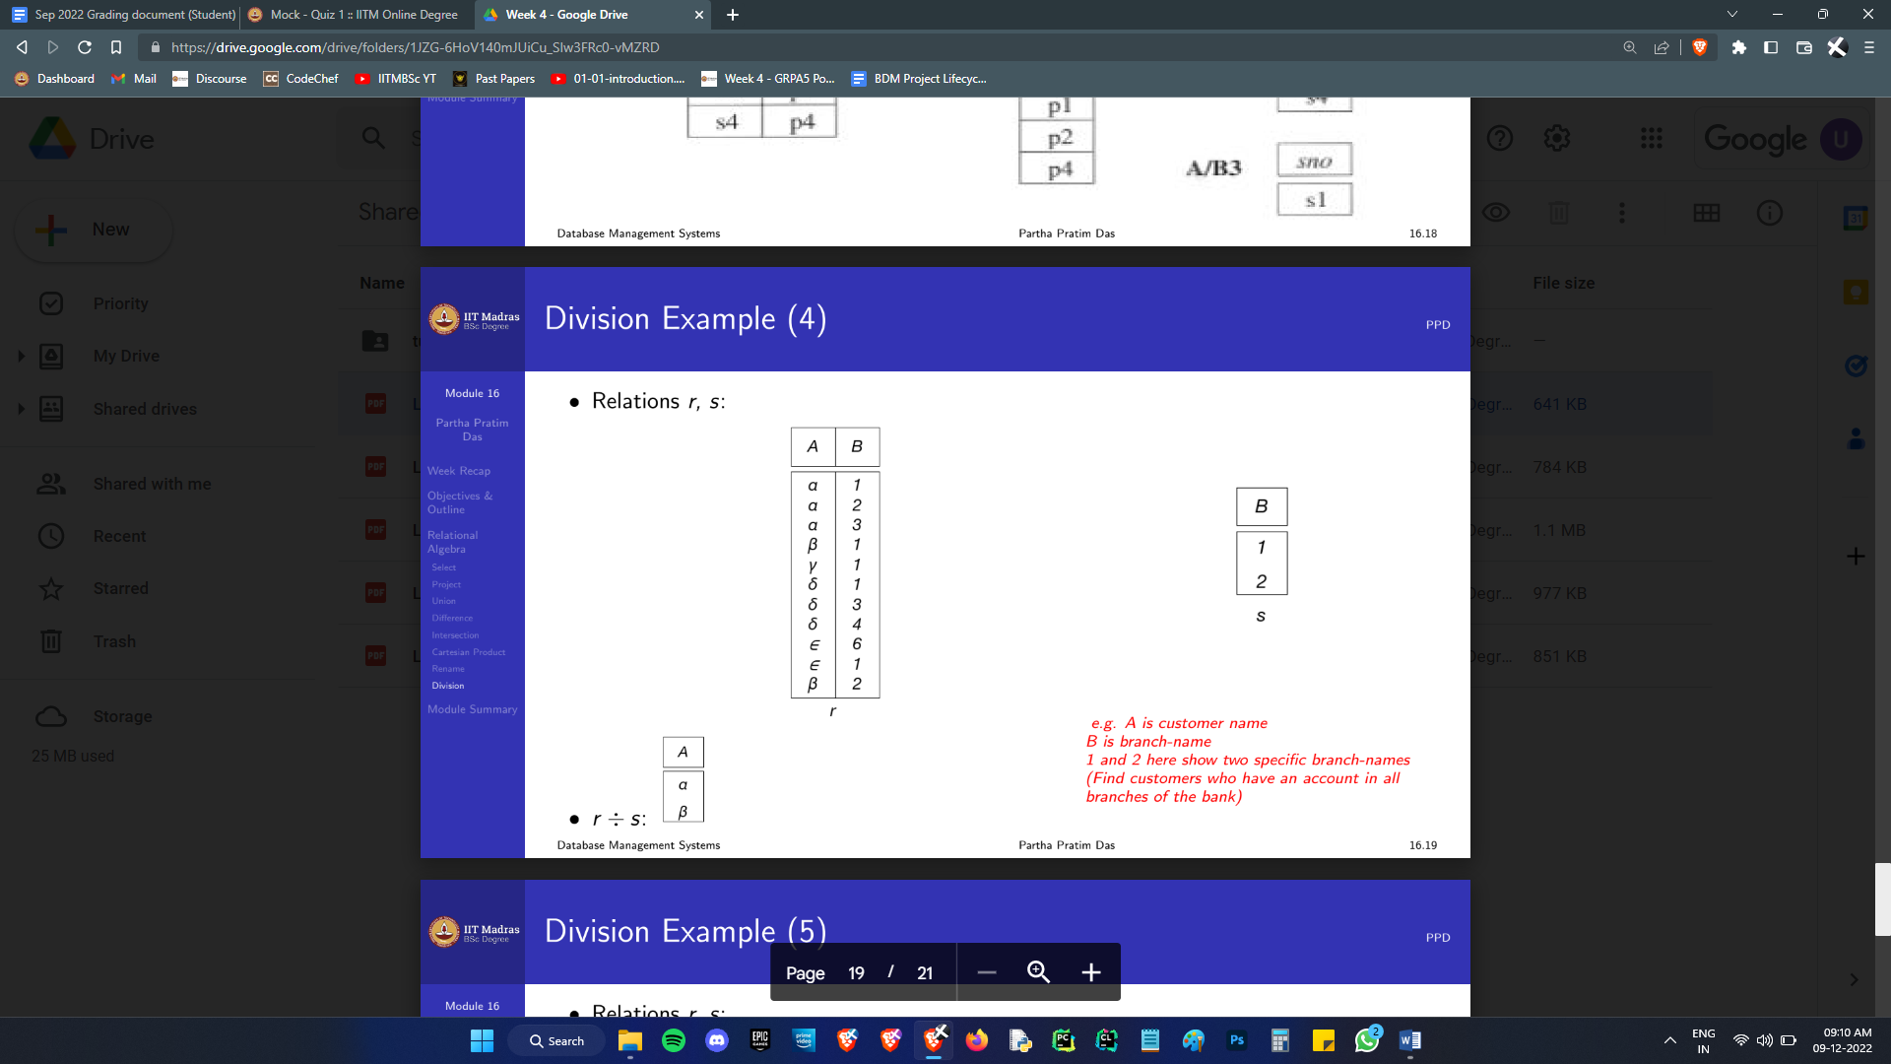

We take the columns R-S, which is only A. We check for tuples in A that occur with every tuple in B, which are onlyαandβ.

(Note: the example finds customers with accounts in all branches in table s, not ***all*** branches. If that is sought, use a subquery to select distinct B from s.)

In summary, we have

σ selection

π projection

ρ rename

× Cartesian product

∪ Union – works only between two relations of the same arity (same no of

Attributes, and each attribute is of the same data type)

– Set Difference; again, only same arity.

÷ Division

The relevance of relational algebra lies in the fact that an SQL query is first converted into a relational algebra expression in the background, and then it’s simplified as algebra before actually being executed.

How to design queries so that they involve minimal computation will the focus of the final week. Having these basic ideas about how relational algebra works is helpful when we study that.

As a heads up for the quizzes, there exist alternative mathematical constructs called relational calculus which are *equivalent* to relational algebra. There are two of these, but honestly, neither is worthy of being called calculus. These people call *Boolean Algebra,* Predicate Calculus. I cannot see where the calculus lies here -_-

Tuple Relational Calculus and Domain Relational Calculus are based on Predicate Calculus. Basically, both are glorified set theory and Boolean algebra.

I won’t bother discussing them here because a) we won’t be using them, and b) if you do see them, it’s possible to understand them directly.

## SQL Syntax

With the general theory down, let’s move on to writing actual SQL.

### Creation

CREATE TABLE TABLE_NAME(HEADING1_NAME DATATYPE CONSTRAINTS, HEADING2_NAME …)

Apart from that, you can also add integrity constraints after all the headings like

CREATE TABLE TABLE_NAME(HEADING1_NAME DATATYPE CONSTRAINTS, HEADING2_NAME …, INT_CONSTRAINT1,INT_CONSTRAINT2… )

Some common datatypes:

Char(n): Fixed string of length n. Less than n characters is not okay.

Varchar(n): Strings of max length n.

Int: Integers upto some magnitude (machine dependent)

Smallint(n)

Numeric(t,d): A total of t digits are allowed, d of which are decimal places. ( Example: 3,1 corresponds to something like 99.9)

Float(n): A floating point number with upto n decimal digits.

Date: Year month day

Time: Time of day in 24 hrs. 09:45:30.15 (Yea, decimal seconds, cozynot)

Timestamp: Date and then Time.

Interval: Subtracting a date/time/timestamp value from another gives an interval value. They can be added to date/time/timestamp values

It’s possible to make custom datatypes, basically aliases, using the following syntax:

create type Dollars as numeric (12,2)

This defines the datatype Dollars.

A more sophisticated way to define custom types is using *domains*, which let you add in constraints:

create domain degree level varchar(10)

constraint degree level test

check (value in ('Bachelors', 'Masters', 'Doctorate'));

Some common constraints:

NOT NULL - Ensures that a column cannot have a NULL value

UNIQUE - Ensures that all values in a column are different

PRIMARY KEY - A combination of a NOT NULL and UNIQUE. Uniquely identifies each row in a table

FOREIGN KEY - Prevents actions that would destroy referential integrity between tables

CHECK - Ensures that the values in a column satisfies a specific condition

DEFAULT - Sets a default value for a column if no value is specified

Among these, the first 3 are straightforward. Just typing them does the job.

The last 3 require some additional syntax.

CHECK (AGE>=18)

DEFAULT 'REGULAR'

FOREIGN KEY (COLNAME) REFERENCES FOREIGN_TABLE_NAME(THE_COL_THERE)

ON DELETE CASCADE

ON UPDATE CASCADE

The cascade statements are optional. Going back to my foreign key example, Relation “Borrowed” has foreign key tables “Students” and “Books”.

If I were to delete a student from the Students relation, the deletion would cascade down to the Borrowed table, instead of preventing a deletion entirely. Any entries for the student having borrowed a book will disappear along with the student.

Update cascades make a lot of sense to keep around. I can’t immediately tell the use case for delete cascade. Alternatives to cascading are: no action, set null and set default. (If a student is deleted, make the borrowed table’s student id as null, or the default.)(In this case it is nonsensical, but it will have utility elsewhere.)

“No action” is the *default*. No action that can break integrity will occur.

### Selection

There are 3 parts to a select query: select from and where.

SELECT A1, A2, . . . , AN,

FROM R1,R2, ...,RM

WHERE P

**The select clause** is the projection operator, selecting a certain number of columns. SQL won’t delete duplicates by default; adding the keyword distinct before a column will delete them.

Selecting multiple columns which must, put together, be distinct, can be achieved with group by syntax, or [this](https://stackoverflow.com/a/12632129) more sophisticated query for optimality.

**The from clause** selects the tables from which we will be making our selection. Giving multiple tables automatically makes it a Cartesian product.

Further, the from clause can use the keyword “as” to rename a table for that query.

SELECT DISTINCT T.NAME

FROM INSTRUCTOR AS T, INSTRUCTOR AS S,

WHERE T.SALARY > S.SALARY AND S.DEPT NAME = ’COMP. SCI’

The Keyword “as” is optional and may be omitted. instructor as T ≡ instructor T

**The where clause** just places constraints on the tuples being selected. The where clause can use a keyword “like”, for string similarity operations:

WHERE NAME LIKE ’%SINGH%’

A “%” matches any string. An “_” matches exactly one character

The where clause allows for the keyword “between”, which checks if low ≤ x ≤ high

WHERE SALARY BETWEEN 90000 AND 100000

where also allows for a tuple equality check:

WHERE (INSTRUCTOR.ID, DEPT NAME) = (TEACHES.ID, ’BIOLOGY’);

where also allows the predicate **in**.

WHERE DEPT NAME IN (’COMP. SCI.’, ’BIOLOGY’)

It’s equivalent to several equality statements connected by an ‘or’ condition. (Yeah, btw, ‘and’ and ‘or’ are both valid things that can be used in where clauses.)

The predicate ‘is null’ can be used to check for null values

SELECT NAME

FROM INSTRUCTOR

WHERE SALARY IS NULL

It is not possible to test for null values with comparison operators, such as =, <, or <>. We need to use the ‘is null’ and ‘is not null’ operators instead. Well, then how does null behave in a normal comparison check?

SQL uses 3 Boolean values, not just 2; they are true, false, and *unknown*. Any normal binary comparisons involving null return unknown. Here is how it behaves with logical operators; it’s really intuitive.

OR:

(unknown or true) = true,

(unknown or false) = unknown

(unknown or unknown) = unknown

AND:

(true and unknown) = unknown,

(false and unknown) = false,

(unknown and unknown) = unknown

NOT: (not unknown) = unknown

Result of the where clause predicate is treated as **false** if it evaluates to unknown.

**The order clause** is optional, and sorts the table by a given attribute, or several attributes. (If several tuples have the name for instance, the ordering among them will be decided by the succeeding attribute you list here.

ORDER BY NAME DESC

This just sorts by name in desc. Not typing desc defaults it to asc. Typing asc also works.

ORDER BY COLUMN1 DESC, COLUMN2

This sorts everything by column1 (descending) first, and then by column2 (ascending, which is the default) whenever the column1 fields for two or more rows are equal.

**The fetch clause**, also optional, can be used to select the top 10 or bottom ten entries.

SELECT DISTINCT NAME

FROM INSTRUCTOR

ORDER BY NAME

FETCH FIRST 10 ROWS ONLY

This isn’t a common syntax though. Oracle uses it. (But it’s *so fetch*)

◦ SQL Server & MS Access support select top

select top 10 distinct name from instructor

◦ MySQL supports the limit clause

select distinct name from instructor limit 10

◦ Oracle uses fetch first n rows only and rownum

At this point, I must introduce **aggregate functions**.

These are fairly straightforward functions that work by looking at the aggregate of some quantity over many records. They are SUM, MAX, AVG, MIN and COUNT.

SELECT AVG (SALARY)

FROM INSTRUCTOR

WHERE DEPT NAME =‘COMP. SCI’;

If I want to know the average salary of instructors in each department, we need to invoke **the group by clause**.

SELECT DEPT NAME, AVG(SALARY) AS AVG SALARY

FROM INSTRUCTOR

GROUP BY DEPT NAME;

(Yes, the as keyword can also rename attributes in the select clause apart from tables in the from clause.)

An important thing to note is that the group by clause can be invoked only if we select *only the argument of the group by, and the aggregate function.* If I ask for, say, instructor name in the select clause, how is it possible to give me a single name for the full department? Such a query is simply incorrect.

The results of the grouped query can then be filtered using **the having clause**. The where clause puts a constraint on which tuples are selected. The having clause puts a constraint on which post-group tuples are displayed.

Find the names and average salaries of all departments whose average salary is greater than 42000.

SELECT DEPT NAME, AVG(SALARY)

FROM INSTRUCTOR

GROUP BY DEPT NAME

HAVING AVG(SALARY) > 42000;

The having and where clauses use the same predicates.

**Set theoretic operations:** If all these clauses are not able to satisfy your needs, you can make multiple convoluted queries and then merge them using basic set theory operations.

The following are examples meant for illustration. The results of the 1st example can be easily achieved using a simple “or”/“and” keyword, but the other 2 make more sense in terms of practicability.

Find courses that ran in Fall 2009 or in Spring 2010

(SELECT COURSE ID FROM SECTION WHERE SEM = ‘FALL’ AND YEAR = 2009)

UNION

(SELECT COURSE ID FROM SECTION WHERE SEM = ‘SPRING’ AND YEAR = 2010)

• Find courses that ran in Fall 2009 and in Spring 2010

(SELECT COURSE ID FROM SECTION WHERE SEM = ‘FALL’ AND YEAR = 2009)

INTERSECT

(SELECT COURSE ID FROM SECTION WHERE SEM = ‘SPRING’ AND YEAR = 2010)

• Find courses that ran in Fall 2009 but not in Spring 2010

(SELECT COURSE ID FROM SECTION WHERE SEM = ‘FALL’ AND YEAR = 2009)

EXCEPT

(SELECT COURSE ID FROM SECTION WHERE SEM = ‘SPRING’ AND YEAR = 2010)

# Week 3 : Intermediate & Advanced SQL

## Nested Queries

Firstly, it is possible to *nest* queries inside the main query. In

SELECT A1, A2, ..., AN

FROM R1,R2, ...,RM

WHERE P

Ai, ri can be replaced by a query in a straightforward way. P can also be replaced by a query using appropriate predicates for the where clause.

### Subqueries in the where clause

There are 5 of these predicates we will look at: *in,* (and *not in):*

SELECT DISTINCT COURSE ID

FROM SECTION

WHERE SEMESTER =‘FALL’ AND YEAR = 2009

AND

COURSE ID IN (SELECT COURSE ID

FROM SECTION

WHERE SEMESTER =‘SPRING’ AND YEAR = 2010);

*some, all*, *exists*, and *unique*. (exists and unique can be prefixed with not.)

Some is an existential question. If there exists some tuple in this set, then it should return true.

SELECT NAME

FROM INSTRUCTOR

WHERE SALARY > SOME (SELECT SALARY

FROM INSTRUCTOR

WHERE DEPT NAME = ’BIOLOGY’);

(salary = some) ≡ (salary in), but (salary ≠ some) **≢** (salary not in).

If there exists even one unequal entry in the set, salary ≠ some works. Not in requires that not even one thing matches.

All is a universal question. (salary ≠ all) ≡ (salary not in), but (salary = all) **≢** (salary in). Makes sense.

Exists returns true if the argument is not a null set.

Find all students who have taken all courses offered in the Biology department.

SELECT DISTINCT S.ID, S.NAME

FROM STUDENT AS S

WHERE NOT EXISTS ((SELECT COURSE ID

FROM COURSE

WHERE DEPT NAME = ’BIOLOGY’)

EXCEPT

(SELECT T.COURSE ID

FROM TAKES AS T

WHERE S.ID = T.ID));

We take a student. We walk into courses table, and get all the bio courses. From that we take away all the courses this student has taken up. If they took up all the bio courses, this will be a null set. Then the not exists will be true. The desired result is achieved.

Unique returns true if there are no duplicates in its argument. Simple.

### Subqueries in the from clause

Find the average of the salaries of the instructors from those departments where the average salary is greater than $42,000

SELECT DEPT NAME, AVG(AVG_SALARY)

FROM (SELECT DEPT NAME, AVG(SALARY) AS AVG_SALARY

FROM INSTRUCTOR

GROUP BY DEPT NAME

WHERE AVG_SALARY > 42000);

Alternatively, we can define a temporary relation (tables are called *Relations*, in case I didn’t mention earlier) using **the with clause** which precedes the select clause.

WITH MAX_BUDGET(VALUE) AS

(SELECT MAX(BUDGET)

FROM DEPARTMENT)

SELECT DEPARTMENT.NAME

FROM DEPARTMENT, MAX_BUDGET

WHERE DEPARTMENT.BUDGET=MAX_BUDGET.VALUE;

### Subqueries in the select clause

These are highly limited because the arguments are supposed to be headings. The subqueries can only return exactly one tuple, so as to constitute one attribute. The returned value becomes the value of the attribute, and the name can be given by the as predicate.

List all departments along with the number of instructors in each department

SELECT DEPT NAME,

(SELECT COUNT(*)

FROM INSTRUCTOR

WHERE DEPARTMENT.DEPT NAME = INSTRUCTOR.DEPT NAME)

AS NUM INSTRUCTORS

FROM DEPARTMENT;

## Modifying the Table data

### Delete

DELETE FROM INSTRUCTOR

WHERE DEPT NAME IN (SELECT DEPT NAME

FROM DEPARTMENT

WHERE BUILDING = ’WATSON’);

delete from instructor will delete all the tuples in the table instructor. A “where” clause is needed to filter out and delete a subset.

Let’s say we want to delete the instructors whose salary is below the average.

DELETE FROM INSTRUCTOR

WHERE SALARY < (SELECT AVG (SALARY)

FROM INSTRUCTOR);

Since the average changes as we delete entries, SQL only uses the original avg prior to any deletion.

In the previous query, you can see that the where clause subquery needs to execute for each tuple. Here, it will run once at the start and then never again,

### Insert

INSERT INTO TABLE_NAME (H1,H2…) VALUES(…);

The headings you don’t give data for are given null values.

INSERT INTO TABLE_NAME VALUES(…)

This requires that you enter data for all attributes.

INSERT INTO TABLE_NAME VALUES(…)

This requires that you enter data for all attributes.

The insert query also permits a select clause, basically a nested subquery but without the brackets, to insert data from another table into this.

INSERT INTO STUDENT

SELECT ID, NAME, DEPT NAME, 0

FROM INSTRUCTOR

The select subquery is evaluated in one go, then insertion is done. This prevents issues from queries like insert into table1 select * from table1

### Update

We wish to increase salaries of instructors whose salary is over $100,000 by 3%, and all others by 5%.

UPDATE INSTRUCTOR

SET SALARY = SALARY ∗ 1.03

WHERE SALARY > 100000;

Then we can do a second query:

UPDATE INSTRUCTOR

SET SALARY = SALARY ∗ 1.05

WHERE SALARY <= 100000;

There is an issue with sending multiple update queries like this. If I had swapped the order of these 2 queries we’d be in trouble; if we first update all instructions lower than 100k and give them a raise, *if* they get a salary *over* 100k after this, a *second* raise will be given when we give a raise to those over 100k.

We want a simple if else statement to be put inside the update statement. A series of if else is better represented as a case sequence, which is what SQL supports:

UPDATE INSTRUCTOR

SET SALARY = CASE

WHEN SALARY <= 100000

THEN SALARY ∗ 1.05

ELSE SALARY ∗ 1.03

END

Yeah, the keywords are trippy. I assume the keyword “when” was chosen because it makes sense to use it over and over, whereas “if” needs a second keyword “else if” to make the same sense. Whatever, I guess.

## Modifying the Table Schema

Preferably, don’t. Have good design before you begin a serious deployment. If you’re doing this to a table with massive amounts of data, something is wrong with you.

* ALTER TABLE TABLE_NAME ADD(HNEW, DATATYPE, CONSTRAINTS…);
* ALTER TABLE TABLE_NAME MODIFY HX DATATYPE CONSTRAINTS;
* ALTER TABLE TABLE_NAME CHANGE HX NEWHEADINGNAME DATATYPE CONSTRAINTS;
* ALTER TABLE TABLE_NAME DROP HX;
* DROP TABLE TABLE_NAME

## Join Expressions

### Cross join

It returns the Cartesian product of rows from tables in the join.

Explicit:

SELECT * FROM EMPLOYEE CROSS JOIN DEPARTMENT;

Implicit:

SELECT * FROM EMPLOYEE, DEPARTMENT;

### Natural join

When an inner join is done on two tables, all the attributes whose names are identical are checked for equality. Only if there is a perfect match, that tuple will make it to the final output.

The inner join is sometimes called a natural join, and is denoted by ⋈

However, the phrase natural join is an umbrella term that can be one of 4 things: inner join, left outer join (⟕), right outer join (⟖), full outer join (⟗). If it is not explicitly mentioned, the natural join is assumed to be an inner join. Since the other ones have a symbol of their own, I suppose it makes a lot of sense.

Natural simply refers to the fact that there are columns with the same name which will get merged.

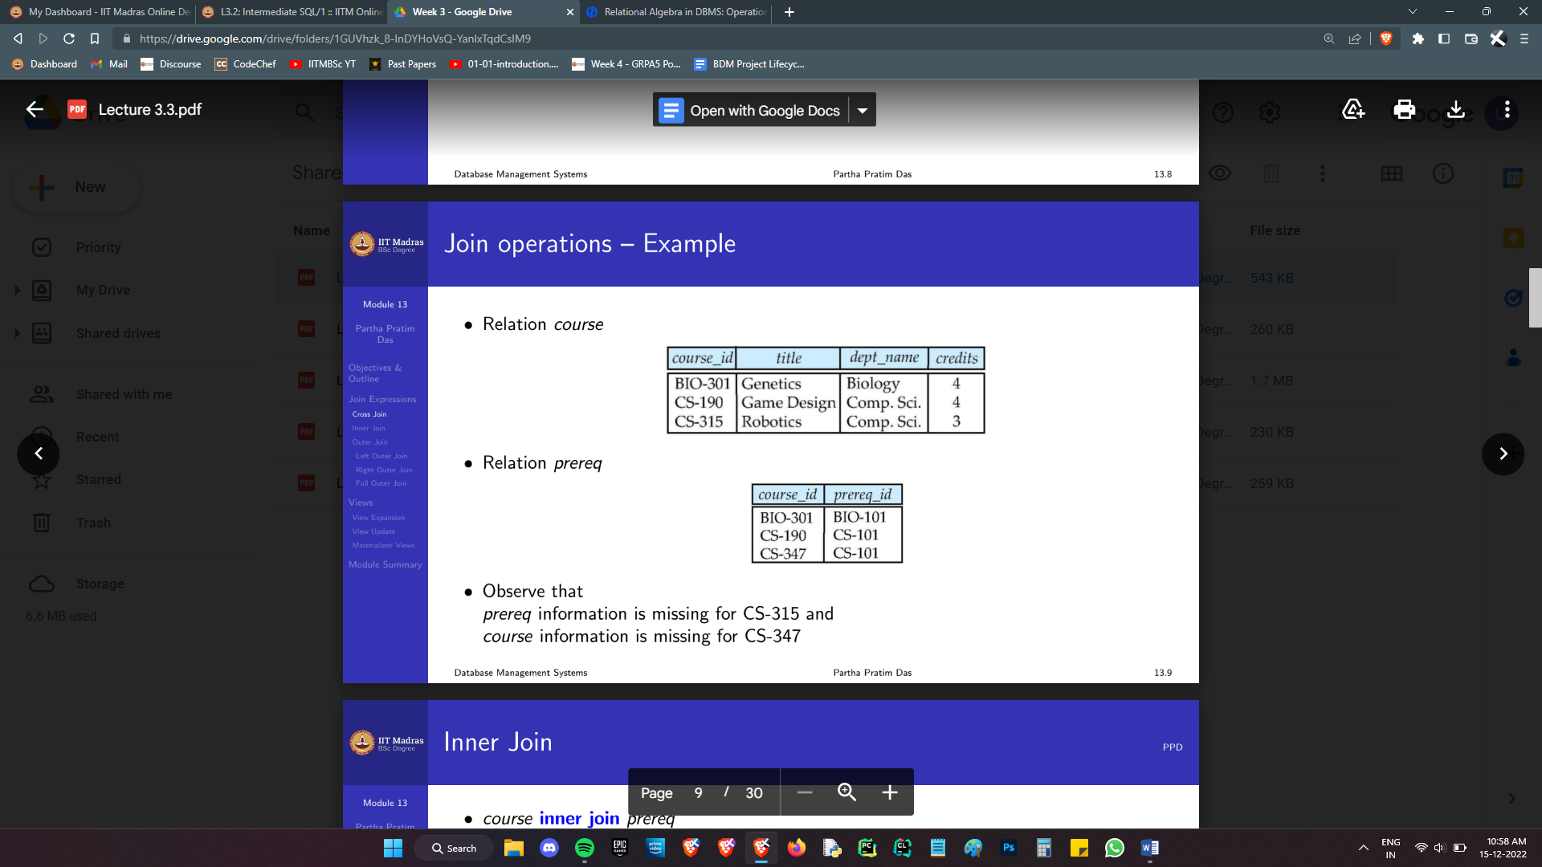Consider two tables, course and prereq:

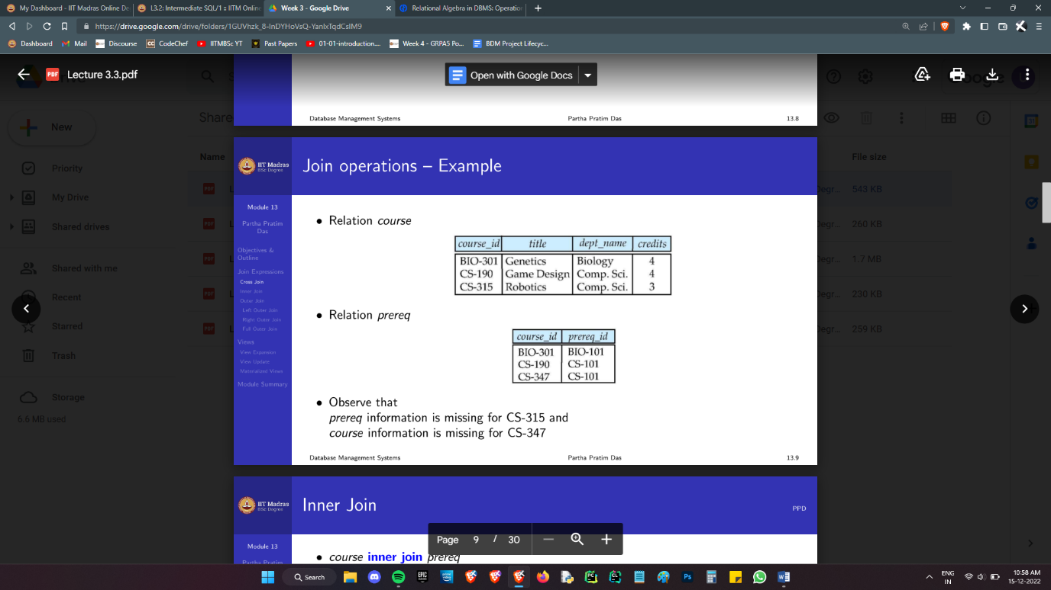

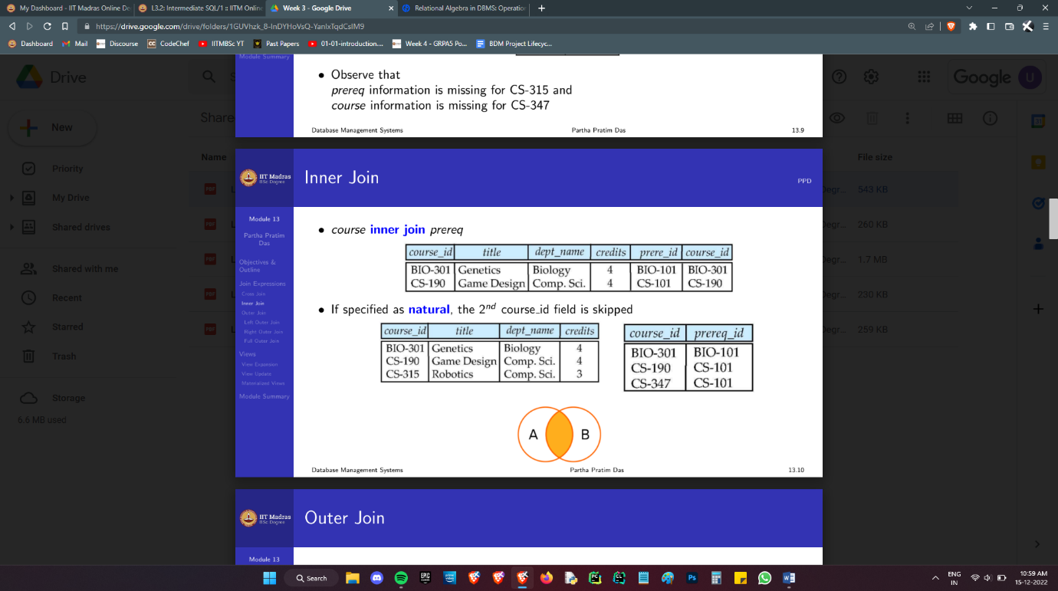course inner join prereq

Observe the presence of a second course_id column at the end. Adding the keyword natural makes this go away. (course natural inner join prereq)

Also note that the entry of CS-315 from course is lost, and so is CS-347 from prereq.

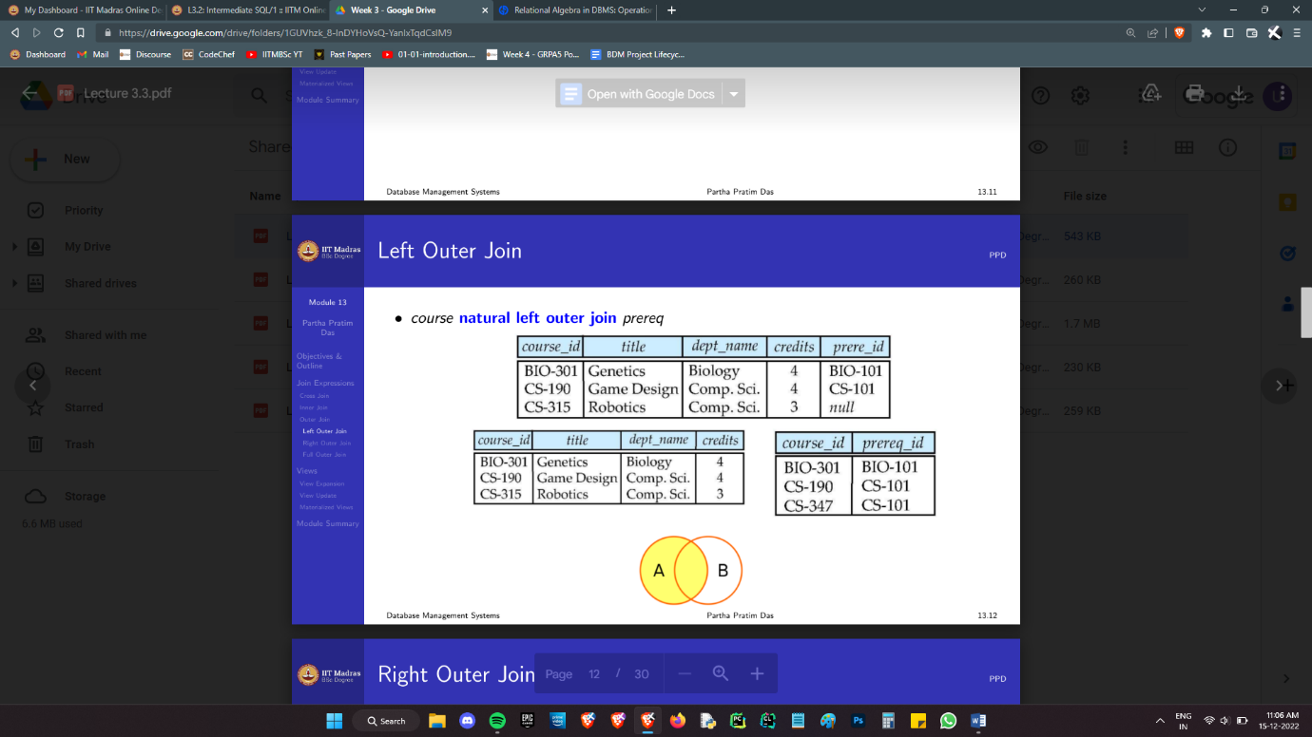If we want to retain CS-315 in course, and have null entries in the prereq table, a totally reasonable thing to do, we use the left inner join. Similarly, if we want right side tuples with left null values, right outer join, and if we wish to preserve all data, then a full outer join.

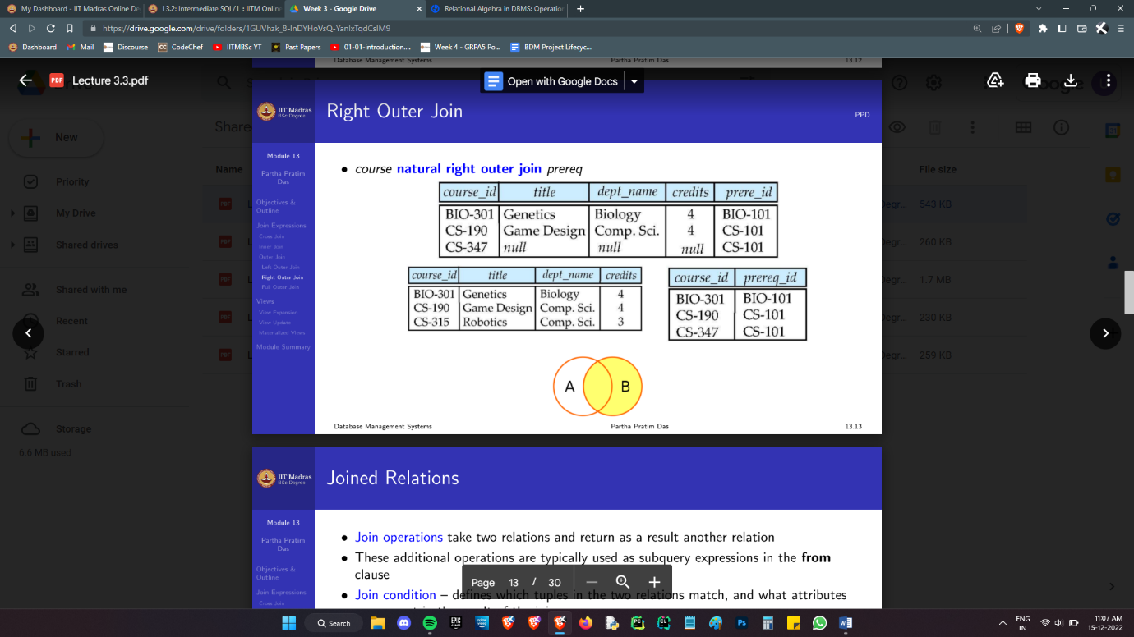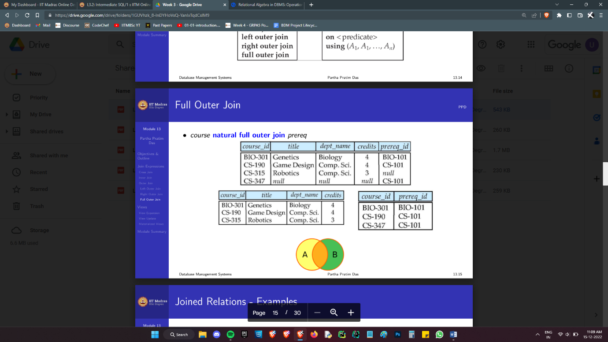The natural keyword merges two relations on *all* common attributes. If we wish to specify a set of attributes on which merging needs to be done, we can use the ‘on’ clause:

SELECT F.FACULTY_LNAME

FROM FACULTY AS F INNER JOIN DEPARTMENTS AS D

ON F.DEPARTMENT_CODE=D.DEPARTMENT_CODE

WHERE GENDER='F' AND D.DEPARTMENT_NAME='MECHANICAL ENGINEERING'

Although joins are a very elegant and basically the only way we can query multiple tables with conditions, the join as we now know it, fundamentally involves a Cartesian product. Each row in table A scans all columns of B for a match. If table a has m tuples, and B, n, then even though a join expression can have at most m+n entries, (full outer with no intersection) we need to consider the mn tuples of the cross join and discard the vast majority.

If we have tables of millions of entries, a brute force join will instantly spell death for the system. Using some indexing/hashing system becomes essential in that case. We will discuss this along with the physical level data structures in week 8.

## Making Views

Often, a DBMS is accessed by a large number of people in an organisation. It may not be desirable for everyone to have access to everything.

To hide certain data from some users, we create views. Views are basically virtual tables. A create view statement is essentially a select query. Consider a table instructor_full. I can create a view instructor_public which selects all columns except salary.

Unauthorised users can use the relation instructor_public like any other. The only difference is that this table doesn’t exist as such, physically. The table’s name acts like a nested subquery that is evaluated on demand. (Note: A view can be materialised as a physical table if this is too computationally intensive and repetitive. Such a material view will require periodic updates to prevent inconsistencies.)

CREATE VIEW FACULTY AS

SELECT ID, NAME, DEPT NAME

FROM INSTRUCTOR

Now, that ‘instructor’ I’m using to build this view, it need not be a physical relation; It could be a view in itself. Viewception.

Typically, only select queries must be run on views. However, it is possible, although highly discouraged, to permit inserts and updates on views. If we have a simple view, the inserted row will adopt null or default values in the invisible columns in the real table. However, if the view is formed out of a join query, there is no clear way to insert entries into the real tables.

A view can depend on any number of views and real tables, and we can treat both in an identical manner. As long as you don’t have recursive view definitions, things are cool.

Apparently, there exist some recursive views that are of *utility*. This matter is presently several detours away and is not relevant.

At this point, there is already a question that is unanswered: how do we set the authority levels for different users? I’ll tackle this next.

## Privileges and Roles

**GRANT SELECT ON COURSES TO U1,U2,U3**

I am granting select privilege to users 1, 2 and 3 on the table **courses**. Select privilege entails being able to read from the database.

Read:

select: allows read access to relation, or the ability to query using the view

Write:

insert: the ability to insert tuples

update: the ability to update using the SQL update statement

delete: the ability to delete tuples.

Alter Schema:

(The following aren’t always the correct syntax; they convey the core idea regardless.)

Index - allows creation and deletion of indices

Resources - allows creation of new relations

Alteration - allows addition or deletion of attributes in a relation

Drop - allows deletion of relations

all privileges: used as a short form for all the allowable privileges

REVOKE SELECT ON **COURSES** FROM U1,U2,U3

Yin and yang. Straightforward.

A very cool way to handle authorisation is using roles. Instead of directly granting each privilege to a set of users, we can do something like:

CREATE ROLE INSTRUCTOR;

…

CREATE ROLE DEAN;

…

GRANT INSTRUCTOR TO DEAN;

GRANT DEAN TO SATOSHI;

Satoshi gets dean privileges. We can change whatever privileges a dean has and it will reflect on Satoshi. We can revoke dean from Satoshi when they stop being the dean.

Nested roles are allowed, as is shown above by granting all instructor privileges to the dean.

Let’s conclude with some more miscellaneous privileges:

GRANT REFERENCE (DEPT_NAME) ON DEPARTMENT TO MARIANO;

Gives Mariano the privilege to reference dept_name in foreign key constraints for the department table.

GRANT SELECT ON DEPARTMENT TO AMIT WITH GRANT OPTION;

The grant option gives Amit the authority to give this particular privilege to others. “The privilege to grant privileges is a privilege.”

REVOKE SELECT ON DEPARTMENT FROM AMIT, SATOSHI CASCADE

REVOKE SELECT ON DEPARTMENT FROM AMIT, SATOSHI RESTRICT

The revoke and cascade options tell how to handle the revoking if there are dependent privileges. I found a very good example on the net:

For example, if user jerry owns the employees table, he can grant tom the ability to select data from the table and to enable other users to select data from the table:

GRANT SELECT ON employees TO tom WITH GRANT OPTION;

User tom can now enable another user to select data from the employees table:

GRANT SELECT ON employees TO sylvester WITH GRANT OPTION;

The grant tom conferred on sylvester is dependent on the grant the table's owner jerry conferred on tom. In addition, sylvester can enable other users to select data from the employees table.

If sylvester creates a view on the employees table, that view depends on the SELECT privilege that tom granted to sylvester. For example:

CREATE VIEW njemps AS SELECT * FROM employees WHERE state='New Jersey'

To remove his grant to tom, all grants tom can have issued, and any dependent objects, jerry must specify REVOKE...CASCADE:

REVOKE SELECT ON employees FROM tom CASCADE;

As a result of this statement, the SELECT privilege granted by tom to sylvester is revoked, as are any SELECT grants issued by sylvester to other users conferring SELECT privilege for the employees table. The njemps view is destroyed.

To prevent dependent privileges from being revoked, jerry must specify REVOKE...RESTRICT:

REVOKE SELECT ON employees FROM tom RESTRICT;

Because there are dependent privileges (tom has granted SELECT privilege on the employees table to sylvester), this REVOKE statement fails, and no privileges are revoked. The njemps view is not destroyed.

## Formula Sheet

Before I move on to advanced SQL, let me summarise all the keywords encountered thus far:

Select:

SELECT

FROM

WHERE

GROUP BY

HAVING

ORDER BY

FETCH

Select DISTINCT

AS (renaming)

WITH clause preceding select can declare a relation for use in the ‘from’ clause. This is equivalent to ‘AS’, but is cleaner.

Where:

LIKE ‘%_%’ (% - any string, _ one character)

BETWEEN (includes both endpoints)

= (tuple equality also valid),>,<,>=,<=,<>,IN (…),IS NULL, IS NOT NULL

Checks can be run with a sub query argument using keywords SOME, ALL, IN, UNIQUE, EXISTS (LAST 3 CAN BE PREFIXED WITH NOT)

Set theoretic operations: UNION, INTERSECT, EXCEPT

Use only single quotes for strings.

Type cast dates using ::date before comparisons.(like this: '2001-06-15'::date)

DELETE

FROM

WHERE

INSERT INTO

VALUES

UPDATE

SET

WHERE (...) CASE

WHEN

THEN

WHEN... THEN...

ELSE

INNER JOIN, LEFT/RIGHT OUTER JOIN, FULL OUTER JOIN.

KEYWORD: NATURAL

USE ON CLAUSE TO ONLY MERGE ON SOME ATTRIBUTES.

CREATE TYPE

CREATE DOMAIN

CREATE VIEW

CREATE ROLE

GRANT

REVOKE

## Some Sample Problems

**1. Write an SQL statement to find the number of book-titles issued on 11th August 2021.**

**2. Write an SQL statement to find the first name, last name of the faculty of the department having department code as 'ME' and who have issued at least one book, such that there are no duplicate firstname-lastname pairs.**

**3. Write a SQL statement to find the unique book titles which are presently issued to 'PG' students but not to any 'UG' students (use member_type)**

**My Answers**

**1.**

select count(bca.title)

from book_catalogue as bca inner join book_copies as bco

on bco.ISBN_no=bca.ISBN_no inner join book_issue as bi

on bi.accession_no = bco.accession_no

where bi.doi='2021/8/11'::date

**2.**

select f.faculty_fname as fn, f.faculty_lname as ln

from faculty as f

where f.department_code='ME' and

exists (select bi.member_no

from book_issue as bi, members as m

where m.member_no=bi.member_no and m.id=f.id)

group by fn,ln

**3.**

with ans(title,mt) as (select bca.title , m.member_type

from book_catalogue as bca, book_copies as bco, book_issue as bi,members as m

where bca.ISBN_no=bco.ISBN_no and bco.accession_no=bi.accession_no and bi.member_no=m.member_no)

select distinct title

from ans as a1

where exists (select from ans as a2 where a1.title=a2.title and a2.mt='PG') and

not exists (select from ans as a2 where a1.title=a2.title and a2.mt='UG')

## Advanced SQL (Functions and Triggers)

As should be obvious at this stage, SQL isn’t turing complete. It certainly cannot compare to C++. Unlike a typical Imperative language, SQL is declarative.

Typically, SQL is embedded inside another such native programming language in any practical application. However, later versions of SQL allow some imperative tools within the SQL system itself. This includes if else statements, function definitions, loops and such.

However, the syntax used for each of these differ amongst the various systems available that use SQL. The vast majority of the SQL we studied is a hard standard basically everyone conforms to. Minor changes may be seen depending on the host DBMS we work with. When we enter this domain though, people start taking a “meh” approach towards the prescribed syntax.

Here is what an SQL function may look like:

create function dept count (dept name varchar(20))

returns integer

begin

declare d count integer;

select count (*) into d count

from instructor

where instructor.dept name = dept name

return d cont;

end

d count is a local variable we declare inside the function. Queries are *still* the instructions we execute. Essentially, when selecting a subset, or even all columns and returning it, a function is acting like a view, evaluating a query when called, but with an input parameter. Functions, are thus *parametrised views*.

Functions however, are only that: a view. They permit only select queries, no updates etc. That is accomplished using what’s known as a procedure. Procedures can also give outputs which can be stored in a variable. The input and output variables are declared up front.

create procedure dept count proc (in dept name varchar (20), out d count integer)

begin

select count(*) into d count

from instructor

where instructor.dept name = dept count proc.dept name

end

Invoking them is simple:

declare d count integer;

call dept count proc(`Physics', d count);

Loops, conditional statements, case statements and such are not conceptually new. If you ever need to use such things, just look up the syntax.

We will now move on to an unfamiliar mechanism of significant importance: Triggers.

Triggers are essentially a function, in a general sense, that are set off when some conditions are met. A Trigger may get fired before or after an insert, update or delete action.

A “Before” trigger can be used to modify input data type, check some fancy conditions before permitting a deletion etc. An “After” trigger may insert or update data in other tables, or perform non database operations, like emailing a person that their password was modified in the database.

Triggers can be dangerous. Consider this example: I am maintaining a table of the employees of a company, and their immediate family. When I add an employee, it fires a trigger that inserts family member details, say, by asking some other table.

That’s a bad idea.

If two members of the same family work in the company, the addition of the 1st member will trigger the insertion of the 2nd. This is again an insertion, which will fire the trigger, adding 1 again. It’s an Infinite loop. There are such crazy edge cases that can crash your system, so triggers need to be designed with care.

I’ve been told, “Triggers are like a packet of lays, once you pop, you cannot stop.”

Triggers may be powerful, but overusing them will add heavy overheads on your every action. Triggers ought to be used very judiciously. Find other ways to accomplish more complex tasks.

This concludes our present study of SQL. However, there are still 2 things I wish to add: 1) Creating Indices, 2) Transactions, and Deferrable Constraints. Since they open up a lot of discussion, they will be added in a later week rather than here.

That’s about it.

yaay.

# Week 4 : The ER Model

## ER diagrams

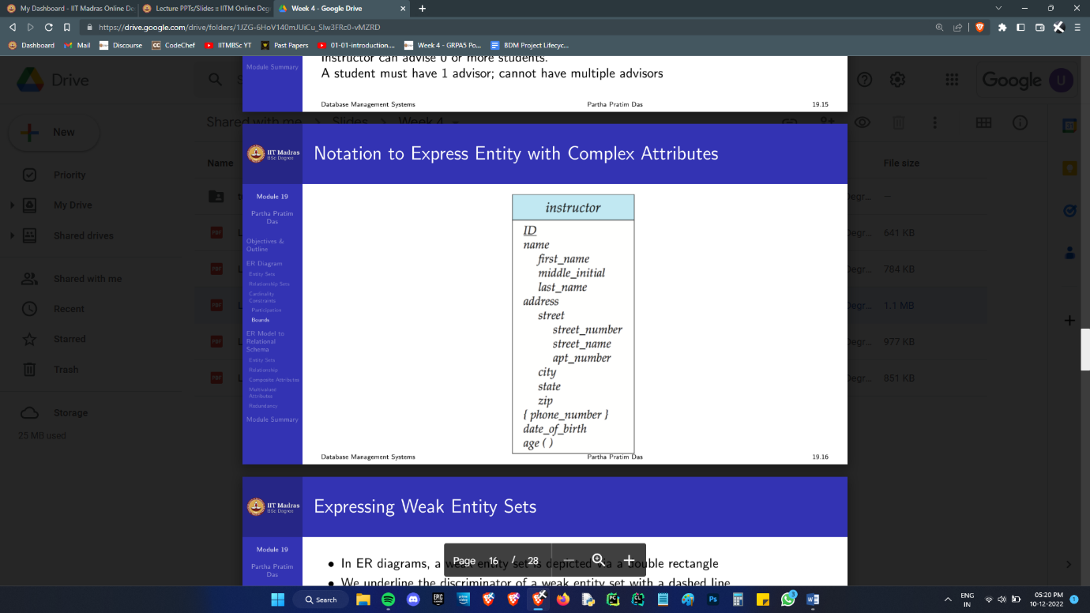An entity is a tuple, representing say, a person’s information. An Entity Set is what we call a table. Entity sets are represented in a straightforward manner:

The underlined attribute(s) together constitute the primary key.

The indented attributes are components of the larger “composite” attributes.

Attributes in {} are “multi-valued”. This means there can be more than one entry for it. I can have 3 phone numbers and it’s okay.

age( ) has the brackets because it’s computed at the time of use. You cannot store the age, because it changes with time. Store the DOB and then compute the date as and when needed.

Now that we can set up tables (not exactly *tables,* but you will see), let’s look at the relationships between them.

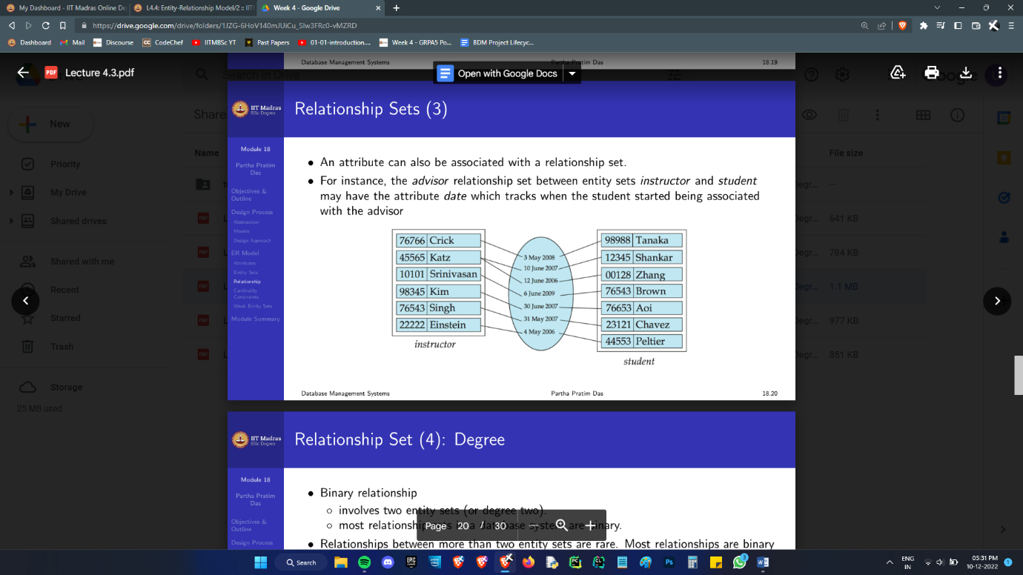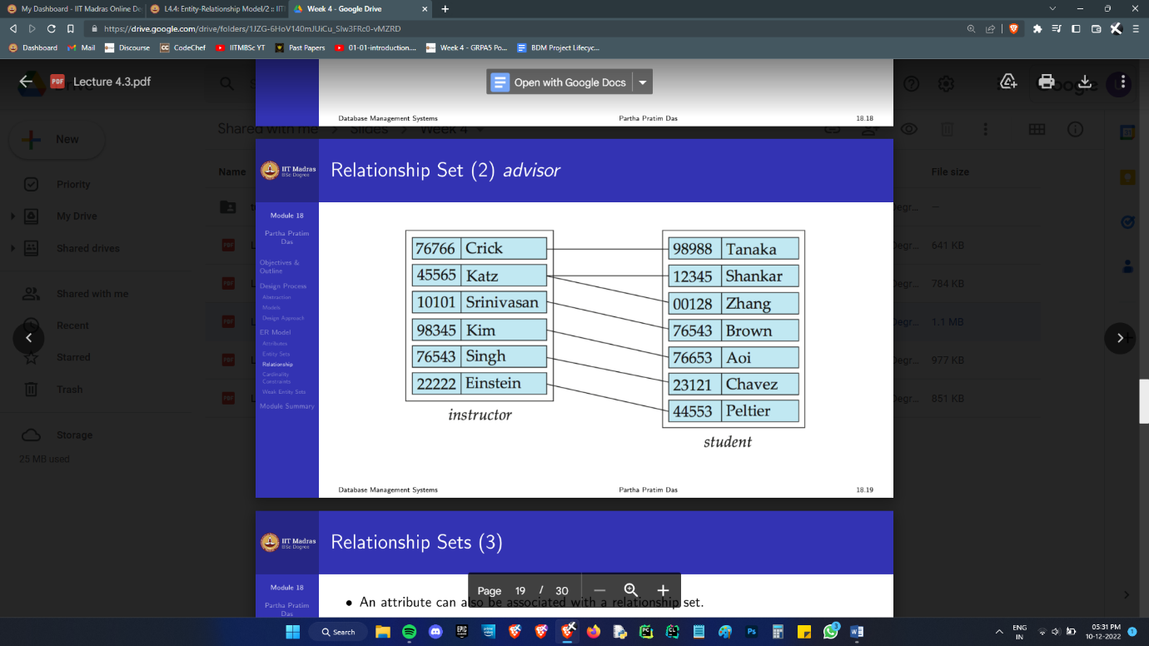A relationship is described by joining entries of one set to the elements of another set.

Notice how, unlike natural inner joining tables, we do not require a common attribute to exist in both entities to establish a relationship.

This means that there exists a very important distinction to be made between the entity sets we study and the actual tables that exist in our database. A relationship *is* the lines that we have drawn here. An entity *is* that row of data we are showing in that box. That’s it.

The second picture above shows a relationship that has an attribute. The given faculty became that student’s advisor, on that given date. Where this is going to end up in our database is not our concern here. It’s not helpful to throw relational data into an *entity* when we study databases with the ER model. That’s not logical in this sense either. If you’re using an ORM like SQLAlchemy, your code will use only entities and relationships, rather than tables, which is insanely convenient.

Going back to the first point I mentioned, if we find that two entities do have a common attribute linking them, we will delete the attribute in at least one of them. Consider:

◦ instructor, with attributes: ID, name, dept_name, salary

◦ department, with attributes: dept_name, building, budget

We model the fact that each instructor has an associated department using a relationship set inst_dept. Since dept_name is the primary key of the department table, we cannot just dump it out and make dept_name an attribute of the relationship. We’ll just delete the attribute from instructor.

**Note:** Actually, I’m not sure if it’s *ever* okay to take an attribute out into a relationship.

If we were to dump dept_name out of the department table, we make an entity without a way to uniquely identify its tuples. Such an entity is called a weak entity. A weak entity cannot make a primary key, even with all attributes, but it has something called a discriminator which can partially act as a key, narrowing down to a small set of tuples. Discriminators are denoted by dashed underlines in the entity box. (Primary keys get a solid underline)

Not any arbitrary subset of the attributes of the entity set is considered the discriminator, the Primary Key of a Weak Entity Set = Its own discriminator + the Primary Key of some other strong entity set to which it is related.

Weak entity sets cannot exist in isolation in an ER diagram. They need to have a relationship with a strong entity set. That’s called the “Identifying relationship.” Weak entity sets must have *total participation* in the identifying relationship. Meaning, all its entities participate in the relationship.

Sound a bit toxic, don’ it?

Anyhow, moving on, in the faculty example, one instructor can belong to only one department. There are cardinality constraints like this in relationships. They are denoted by arrow marks. An arrow mark indicates only one on that side. No arrow = many on that side.

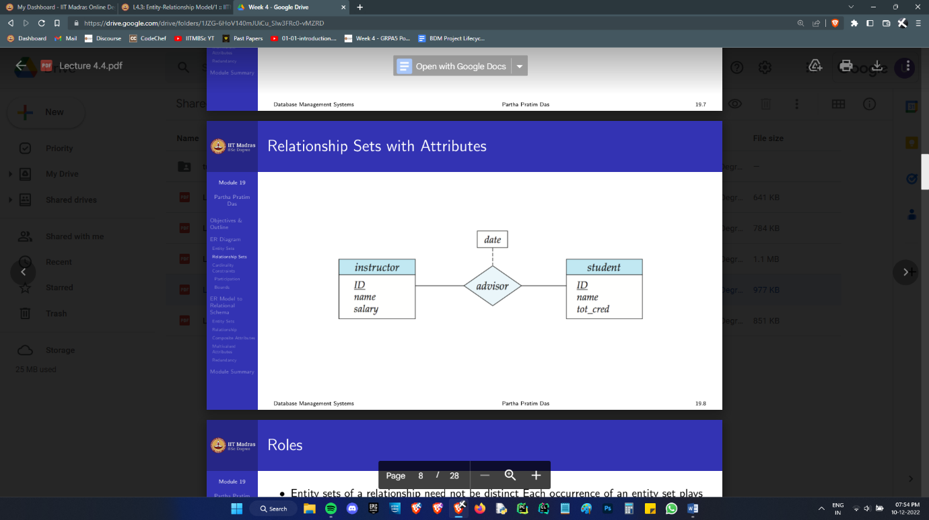Time for some visuals:

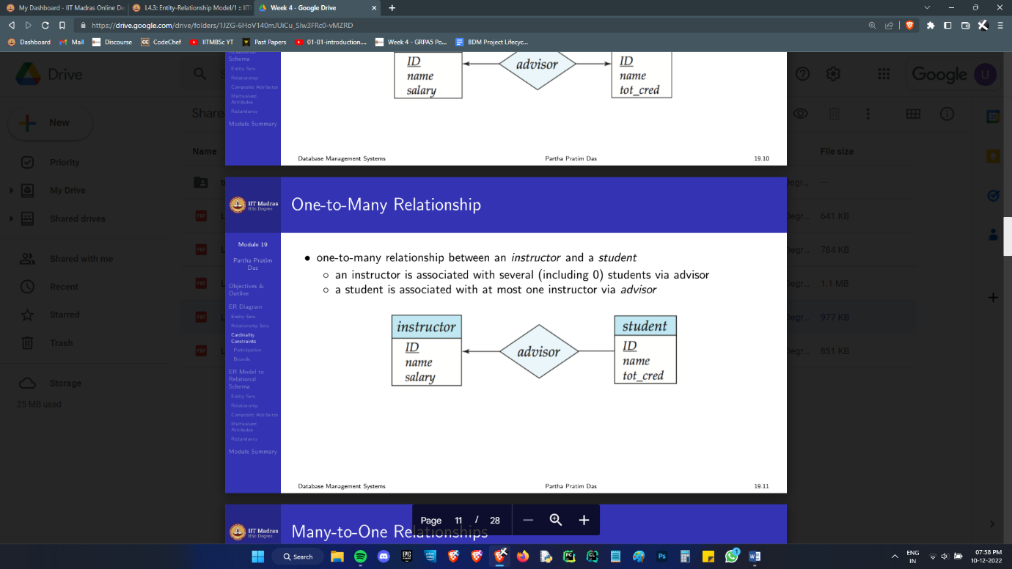A relationship with an attribute

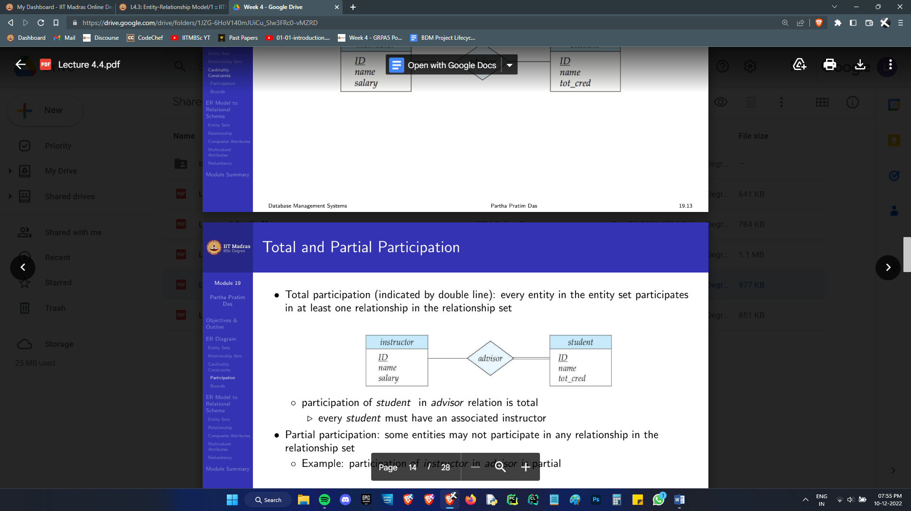

A double line indicates total participation. No student can get away without a faculty advisor.

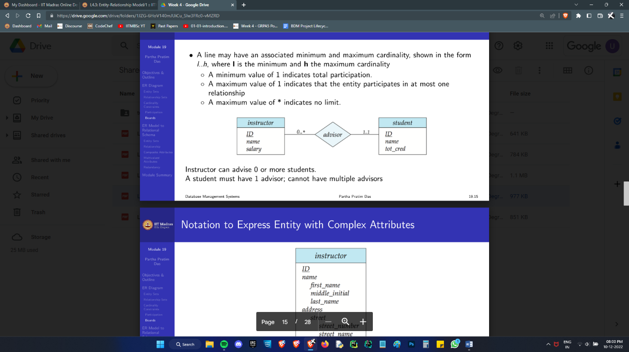The arrow mark indicates that a student can have only one facad. The lack of an arrow on the student side tells that a prof can have multiple students (even *nobody*) under them.

This diagram shows both the above constraints together, in a manner that can be used to represent much more complex constraints. A given instructor participates in 0 or more relationships. There is no upper bound for the number of relationships so we denote it by a *. A given student participates in a minimum of 1 relationship, so it implies total participation, and a maximum of 1 implies that each student can have exactly one facad.

Identifying relationships are symbolised by double bordered diamonds, and weak entities by double bordered boxes.

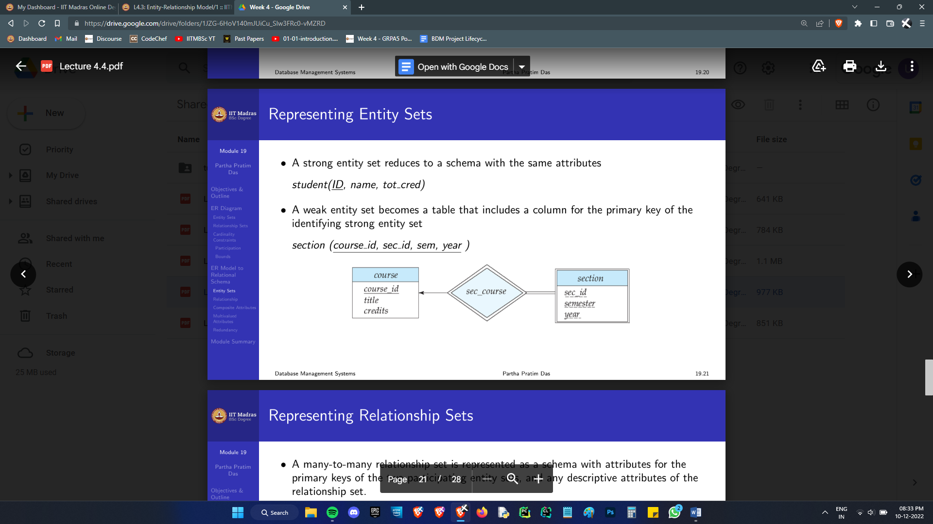There is one quirky thing we may need to be concerned about:

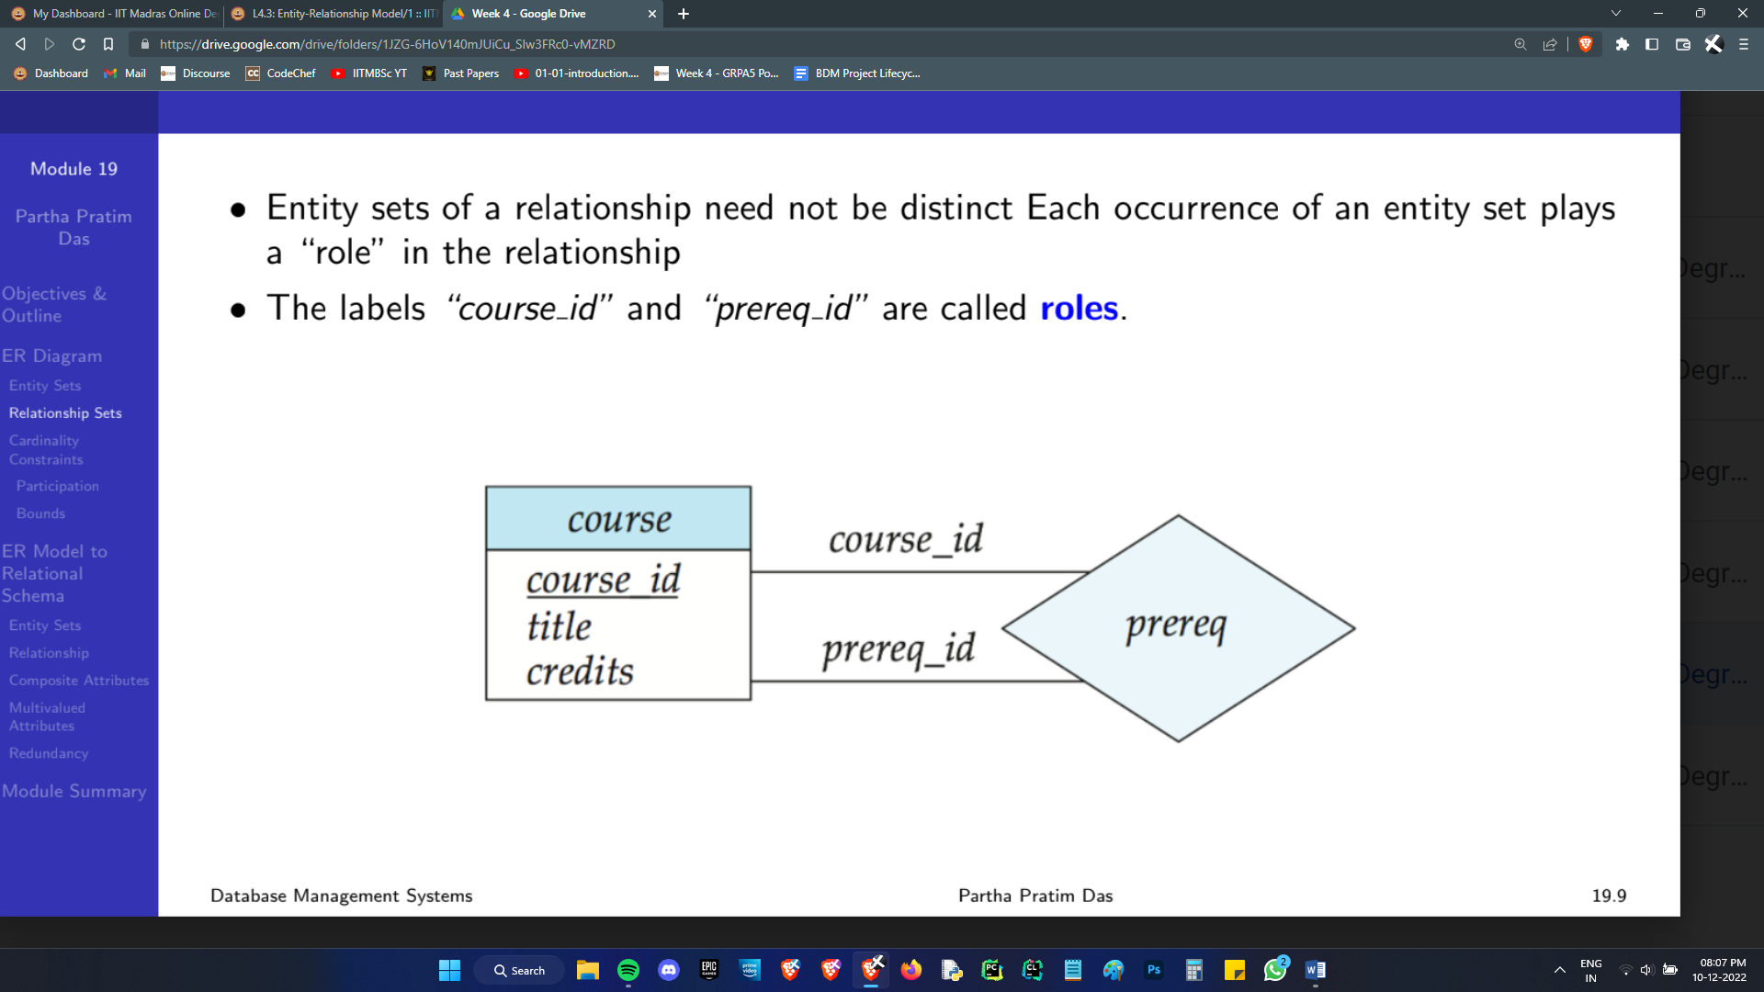

Some entities have a relationship with themselves. A given course_id is associated with any number of prerequisite course_ids. A given course_id may also act as the prerequisite for any number of courses.

Don’t think about it in terms of tables. It’s a relationship of entities to entities.

Well. That’s not the first time I said that. We really need to go to tables though. That’s how a database is.

## ER to Schema

First, Entity Sets:

• A strong entity set reduces to a schema with the same attributes

• A weak entity set becomes a table that includes a column for the primary key of the identifying strong entity set

• Any composite attribute is flattened out by creating a separate attribute for each component attribute.

• A multivalued attribute M of an entity E is represented by a separate schema EM which has attributes corresponding to the primary key of E and an attribute corresponding to multivalued attribute M. If I have 3 phone numbers, I’ll have 3 rows, each with one phone number associated with my identifying primary key.

(Side note: Think about how else you can handle a variable number of phone numbers. Multiple attributes, ph1, ph2..? How many attributes will you even have? How will you query them? What if we had just one common attribute with a list entity as a data point? It’s not *atomic*. That’s not cool.*

If you make multiple rows, each with one phone number, you’ll have a very long row of mostly redundant data. Redundancy leads to Anomaly. Maintaining a separate table with just the primary key and many rows of phone numbers seriously cuts down on the redundancy.)

*Kinda. Some DBMS allow it, sorta. But atomicity is highly desirable.

Next, Relationships:

• A many-to-many relationship set is represented as a schema with attributes for the primary keys of the two participating entity sets, and any descriptive attributes of the relationship set.

For example, the schema advisor (student_id, faculty_id) describes a relationship. *Descriptive attributes* refer to the date at which the advising started and such things.

Although this is a strategy that can work for all relationships, we can get away without making a separate table for the relationship in the other cases:

• Many-to-one and one-to-many relationship sets that are *total* on the many-side can be represented by adding an extra attribute to the “many” side, containing the primary key of the “one” side. This is the “natural inner join” take on the matter.

If participation is partial on the “many” side, this could result in null values in the unrelated tuples.

• For one-to-one relationship sets, a primary key can be added to either of the tables. Again, unrelated tuples will have a null value.

As an obvious add on, the schema corresponding to a relationship set linking a weak entity set to its identifying strong entity set is redundant, because we added the primary key of the strong set in the weak entity set’s table when we designed it, essentially already taking care of the relationship mapping.

ER is a brilliant tool for database design and review. It lets you grasp the situation at a glance and make complex design decisions without having to think in the abstract. However, design using the ER model relies heavily on judgement and intuition, so it may result in a few bad design choices.

Here are the most pressing design choices often confronted:

* If a real-world concept is best expressed by an entity set or a relationship set
* The use of an attribute or entity set to represent an object
* The use of a strong or weak entity set
* The use of a ternary relationship versus a pair of binary relationships
* The use of specialization/generalization {contributes to modularity in the design}
* The use of aggregation { can treat the aggregate entity set as a single unit without concern for the details of its internal structure}

To act against the bad design decisions we may inadvertently make, a Schema generated in the above manner is tested and refined, in a rigorous manner using normalisation theory. (Next week)

Once the final schema has been designed, the ER model becomes less useful when we wish to understand the actual Relations in the Schema. Commonly, diagrammatic depictions are done with crow’s feet notation to fulfil this need.

Before we move on to Normalisation, the last 3 design choices mentioned above demand some discussion.

## Complex ER Aspects

In general, any non-binary relationship can be represented using binary relationships by creating an artificial entity set. We can associate each of the entities involved with a common entity in E. The issue with this is that translating ternary constraints into binary ones can be challenging.

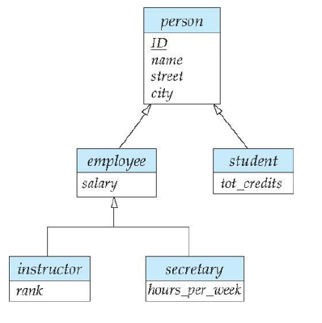This is an example of specialisation. The old symbols had ISA written on the arrow heads, but it’s now taken to be implied.

Employee “is a” person. Instructor ISA employee.

Instructor and secretary are disjoint, shown by a single line splitting into 2 boxes. Employee and student are overlapping.

Employee, student etc. are “specialisations” of the lower entities. They inherit all the attributes of their parent.

This is a design approach akin to class inheritance. Another approach is that of generalisation. Although the diagram we see is *exactly* the same regardless of the approach, a generalisation generalises multiple entities to have a common parent. Bottom up, rather than Top down.

In these diagrams, the word total may be written in dashed lines near an entity. Let’s say the student entity has specialisations UG and PG. Any given student must necessarily fall into either one of these. This makes the specialisation *total*. The other case is naturally called *partial*.

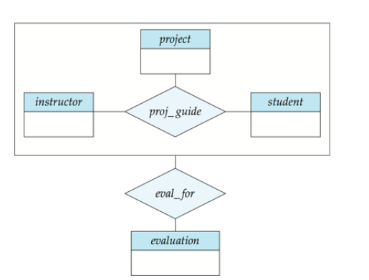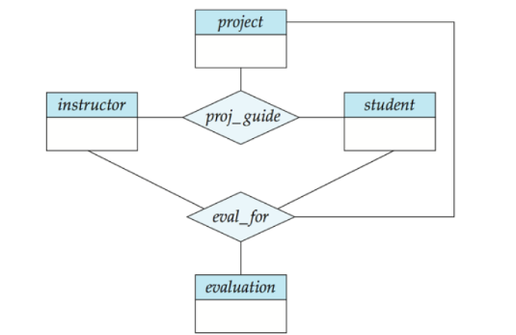Finally, aggregations:

It’s the idea that some set of entities and relationships can be viewed as a single entity without having to worry about its internal working. In the first figure above, a student is associated with an instructor and a project. The 3 are also related by the evaluation that is to occur. Some projects may not get evaluated. Others will have all sorts of details about the evaluation. So really, there isn’t any way to get rid of the evaluation table, and there isn’t any way you can represent it without 2 ternary relationships.

In the second diagram, the 3 entity relationship set is associated with the evaluation table, eliminating redundancy of having to relate 3 entities again. That’s some sensible abstraction.

With a brief overview of these down, I think we are capable of not freaking out when we need to use ER diagrams irl. With that, we can move on to normalisation theory.

# Weeks 5 & 6 : Normalisation (Add MVD math)

As discussed earlier, redundant information storage in a database is bad.

To counteract this, in the example discussed, we decomposed the table into two smaller ones, in such a way that no information is lost. Not all decompositions preserve information like that, so we need to be careful about how we break our databases.

As hallmarks of good design, we do something called normalisation to a database. There are many levels to this, each with a greater constraint.

## Functional Dependencies

Before we move on to the normal forms, we must discuss functional dependencies, since we will keep using their formalism. It’s a simple concept: An attribute being capable of nailing down, *determining*, some others. Like how a student’s roll number deterministically tells you the students name etc. etc.

Consider a relation with 3 attributes, α β γ.

Note: read → as “determines”, or as “functionally determines”.

Given {α → β and β → γ} we can infer α → γ. So, α → αβγ. That is, α can uniquely determine the tuple of the relation. It is a candidate key.

Well, if the Closure Set α + (Think of it as the set of all attributes α can determine) of a set of attributes α, is equivalent to the entire Set of the relation, then α is a superkey. If there are no proper subsets of α that can also satisfy that, *then* α is a candidate key.

The above is the closure set of attributes. People also speak of closure sets of a set of functional dependencies. Given a set of dependencies F, F+ is the set of all irreducible* functional dependencies that can be derived from them.

F = {A → B, B → C}

F+ = {A → B, B → C, A → C}

The attribute closure is more commonly useful, though. For instance, if we are asked if a particular function dependency α → β holds, that is, if it ∈ F+, then, we can just check if β ⊆ α+. Further, it is possible to find F+ by merely doing attribute closures, in a while loop, till things stabilise.

*when I said irreducible I mean something like this: F = {A → C, AB → C} Here, B is extraneous in AB → C.

Moving on, here are some obvious Functional dependency rules that we may want to use in our attempts to determine α+ when the situation calls for it:

◦ Reflexivity: if β ⊆ α, then α → β

◦ Augmentation: if α → β, then γα → γβ

◦ Transitivity: if α → β and β → γ, then α → γ

The above are called Armstrong’s axioms, but really, they are provable from the more fundamental aspects of relational algebra, and aren’t really axioms in the mathematical sense. The below are trivially derived from the “axioms” stated above:

◦ Union: if α → β holds and α → γ holds, then α → βγ holds

◦ Decomposition: if α → βγ holds, then α → β holds and α → γ holds

◦ Pseudotransitivity: if α → β holds and γβ → δ holds, then αγ → δ holds

## 1NF and BCNF

A relational schema R is in First Normal Form if

◦ the domains of all attributes of R are atomic

Non-atomic values complicate storage and encourage redundant storage of data.

◦ the value of each attribute contains only a single value from that domain

No “I have 3 phones” inside one entry of a table.

We choose this as the start to normalisation because the absence of this seriously complicates how we computationally handle databases, severely impacting complexity of the transactions we will be doing over and over.

The simplest way to put a relation in 1NF is to squish multivalued attributes into one column.

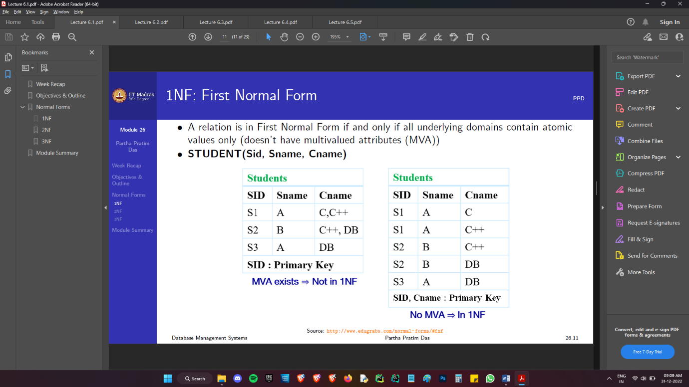

As you can observe, things are objectively shittier. SID has ceased to be a primary key. Although it’s fairly obvious why that’s a problem, here is a mathematical way to see it:

If α → β is a non-trivial FD, and α is *not* a superkey of R, then α can *repeat,* and when it does, β is guaranteed to repeat. That’s redundancy right there.

*Some* functional dependencies are bad, and non-trivial FDs α → β, where α is *not* a superkey are all **bad** FDs.

A relation schema R is in BCNF with respect to a set F of FDs if

∀ FD ∈ F+ of the form α → β, where α ⊆ R and β ⊆ R,

At least one of the following holds:

◦ α → β is trivial (that is, β ⊆ α)

◦ α is a superkey for R

In general, if there exists a bad dependency α → β in R, then break R into

The new small table

• α ∪ β

And the rest. But, we need to keep a copy of the small table’s primary key attributes, which is α, so just dump out β from R.

• R – β

We assume that α and β are disjoint. (A very reasonable thing)

In the extremely general case where α and β may be overlapping, the second piece is (R − (β − α))

A non-null α ∩ β means that something can be removed from β at the dependency stage, since it is a trivial contribution. I get that we are trying to be general here, because we are doing math, and mathematicians get triggered over this, but I despise this split up.

I would like to deal with this in another way:

If ∃ a non-trivial dependency α → β in R, where the dependency is in the simplest possible form, and α is not a superkey for R, R is broken into α ∪ β and R – β.

Now I need to define “simplest possible form”. This is done later. Don’t worry for now.

This decomposition is guaranteed to be lossless. For a given decomposition to be lossless, the following must hold:

◦ R1 ∪ R2 = R

◦ R1 ∩ R2 → R1 or R1 ∩ R2 → R2

(Common attribute must be a key for at least one relation (R1 or R2) so that we can then have R1 ⋈ R2 = R)

As a simple way to discard a lot of the garbage splits I encounter in tests, it’s worth noting that R1 ∩ R2 ≠ Φ, an obvious conclusion from the second criterion.

(α ∪ β) ∪ (R – β) = R

(α ∪ β) ∩ (R – β) = α, and α → β ⇒ α → R2

Hence the BCNF decomposition is lossless.

## Third Normal Form

Sometimes, the BCNF is not terribly useful.

R = CSZ; F = {CS → Z, Z → C}; Key = CS

CS → Z satisfies BCNF, but Z → C violates

Decompose as: R1 = ZC, R2 = CSZ − (C − Z) = SZ

However, now it’s a real pain to enforce functional dependencies. When we have ZC and ZS, we cannot check if CS → Z without first doing a natural join. That is, although our decomposition is lossless, it is not *dependency preserving*. I cannot perform a check without a join.

To subvert this, we minimally weaken the BCNF to make the 3rd Normal Form.

A relation schema R is in 3NF with respect to a set F of FDs if

∀ FD ∈ F+ of the form α → β, where α ⊆ R and β ⊆ R,

at least one of the following holds:

◦ α → β is trivial (that is, β ⊆ α)

◦ α is a superkey for R

◦ Each attribute in β − α is contained in a candidate key for R

(Note: Each attribute may be in a different candidate key)

Clearly, anything in BCNF is automatically in 3NF. The 3rd condition is the way to escape from the first 2, when needed to guarantee functional dependency.

Again, I hate that β – α, so let’s think of the 3rd condition as:

For α → β, in the simplest form, β is entirely made of candidate key pieces. These are called *Prime Attributes*.

Now, how is that a sensible way to ensure dependency preservation? How is this the minimal way to achieve this? I’ll get to that in a minute.

## Canonical Covers

On the topic of checking dependencies, we may have a very large set of dependencies with a lot of redundant detail which is very hard to check and maintain. For instance, there may be extraneous attributes in the dependencies.

Note: This procedure is also needed in order to put a given relation in 3NF.

Two functional dependency sets F & G are said to be equivalent if F+ = G+.

Consider a set F of FDs and the FD α → β in F.

◦ Attribute A is extraneous in α if A ∈ α and F is logically equivalent to the set

(F − {α → β}) ∪ {(α − A) → β}.

That is, deleting A from α doesn’t affect the dependencies in any way. Similarly,

◦ Attribute A is extraneous in β if A ∈ β and the set of FDs

(F − {α → β}) ∪ {α → (β − A)} logically implies F.

We want to know how to do a minimum amount of work to ensure *all* functional dependencies hold. Getting rid of extraneous attributes is the first step. The minimal set we are after is called a Canonical Cover.

A Canonical Cover for F is a set of dependencies Fc such that ALL the following properties are satisfied:

◦ Fc+= F+ (That is, they are equivalent)

◦ No functional dependency in Fc contains an extraneous attribute

◦ The left side of every functional dependency in Fc is unique. That is, there are no two dependencies with equivalent LHS: α1 → β1 and α2 → β2 such that α1 = α2 (That is,α1 → α2 **and** α2 → α1)

We need to be ***really*** careful when we work with these.

R = (A, B, C)

F = {A → BC, B → C, A → B, AB → C}

A → BC implies A → B, so, we can dump A → B.

AB → C is automatically implied by B → C.

Set is now F = {A → BC, B → C}

However, C is now extraneous in A → BC. B→ C , so A → B conveys all the required information.

To be rigorous, Try deleting C in BC. {A → B, B → C} is logically equivalent to the older F, because A → C has not been lost.

Just to reiterate, to check if C is extraneous in A → BC, check if what we are trying to delete, A → C, is inferable from the set that will be created by its deletion, that is, A → B ∪ rest of F.

RHS attribute deletion only asks if you can derive what you are deleting from the new set. That way, nothing is lost. LHS deletion seems more complex, because we are modifying the dependency on a more fundamental level.

So, the way to check if say, A is extraneous in ABC → XY is by taking the new BC → XY, and asking, “does the original set actually imply this?”

I’m just rephrasing the general statement which asked us to compare the entire FD sets to account for the fact that at a time exactly one thing has changed, and that does not screw anything up.

That’s how we put a given set of functional dependencies in its simplest form, the canonical cover. In order for a relation to be in 3NF, we take the Canonical cover, and ensure nothing in this is lost.

Going back to the definition, we did *not* want to remove some dependencies. When we remove a dependency α → β and do a decomposition, the relation R *loses* the attribute set β. The dependency α → β has not been lost, but any other dependencies involving β in R, are now lost.

These can either be γβ → δ or δ → γβ.

Now, since β is the target of α → β, γβ → δ is equivalent to γα → δ, which is not lost. (????)

In δ → γβ, if β were non-prime, then, (SHOW THIS WORKS MATE!)

## Understanding the Normal Forms

We started off with 1NF, ensuring if R has only single valued atomic attributes.

We noted that non-trivial FDs α → β, where α is *not* a superkey are all **bad** FDs.

However, we then realised that that is a tight condition. We descended down to the 3rd Normal form.

There’s another way to get to the 3NF: climbing up from 1NF, weeding out smaller portions of bad FDs, stage by stage.

Relation R is in 2NF if:

◦ R has only single valued atomic attributes (R is in 1NF)

◦ R contains no Partial Dependency.

Here is how I understand this: You’ll have a primary key determining all attributes. If a *subset* of the primary key *itself* can determine some attributes, that is, you don’t need the entire key in order to nail down elements, you have a *partial dependency*.

In less abstract terms, a partial dependency exists in a relation R, if ∃ a non-trivial dependency α → β in R, where α is a proper subset of a candidate key for R, and β is comprised entirely of non-prime attributes.

Now, the naïve 1NF squishing is no longer acceptable. Let’s say there exists a multivalued attribute. A primary key will determine the entire row. When we squish this attribute out, the previous key ceases to be one. However, it can still functionally determine the row *except* for the multivariate attribute we just squished into many rows. That’s a partial dependency.

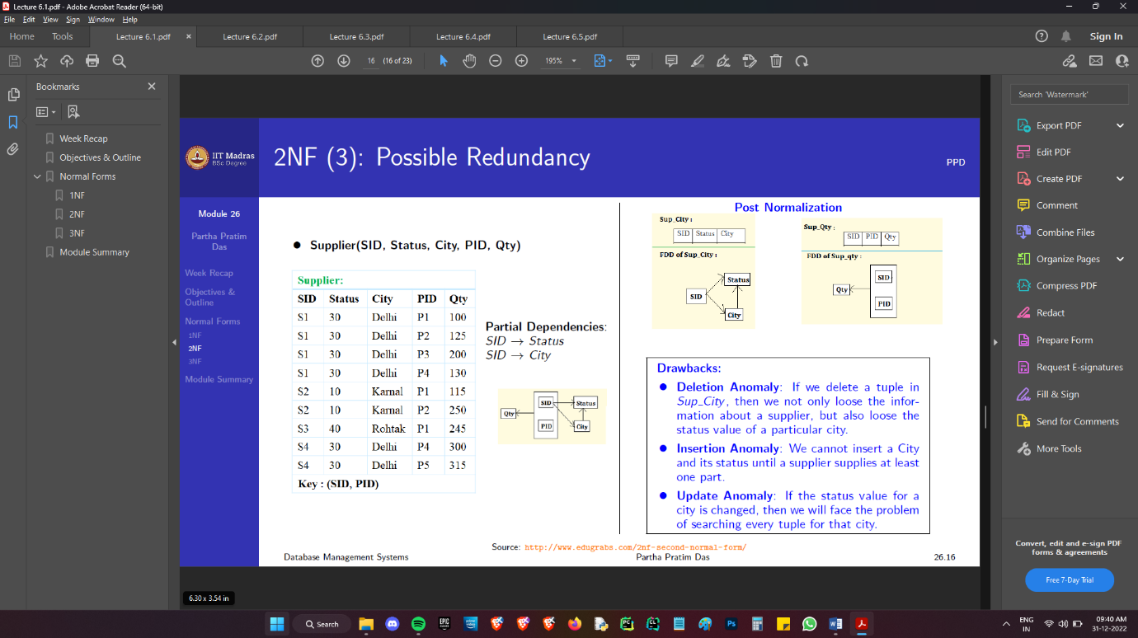They’ll all need their own tables now.

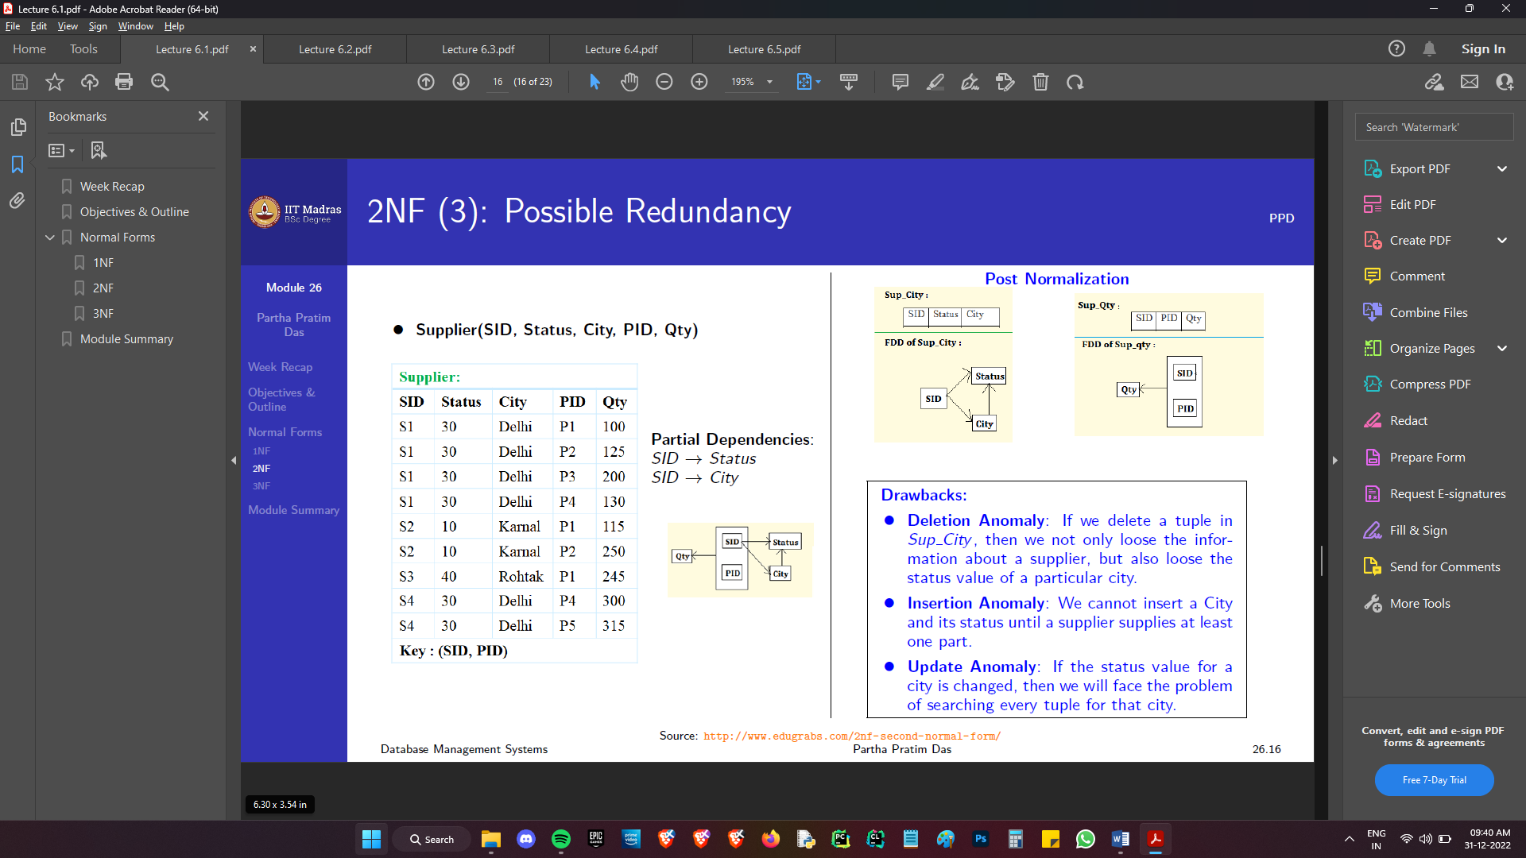Looks good to me.

Drawbacks:

* Deletion Anomaly: If we delete a tuple in Sup_City, then not only do we loose the information about a supplier, but also the status value *of* a particular city.
* Insertion Anomaly: We cannot insert a City and its status until some supplier supplies to that city.
* Update Anomaly: If the status value for a city needs to be changed, then we will face the problem of searching every tuple for that city.

Okay, looks to me like City determining Status is the problem here.

Let’s try to properly tear dependencies into a number of disjoint and exhaustive pieces.

A FD α → β can be:

• Trivial, β ⊆ α (Always allowed.)

• Non-Trivial

◦ α is a superkey (Always allowed.)

◦ α is not a superkey (Completely removed in BCNF)

1. β is entirely prime (Only thing allowed in 3NF)

2. β is entirely non-prime, α ⊂ a candidate key

3. β is entirely non-prime, α **⊄** a candidate key

4. β is some mix of prime and non-prime.

Only removing 2 Gives 2NF. Removing 2, 3, 4, gives 3NF. Removing all 4 gives BCNF.

Informally, a relational database relation is often described as “normalized” if it meets the third normal form. Most 3NF relations are free of insertion, update, and deletion anomalies.

Relation R is in 3NF only if:

◦ R is in 2NF

◦ R contains no transitive dependency of a non-prime attribute on any key of R.

Equivalently: Every non-prime attribute of R is non-transitively dependent on every key of R.

Let α and β be sets of attributes such that α→β holds, but β→α does not hold. Let A be an attribute that is not in α, is not in β, and for which β→A holds. We say that A is transitively dependent on α.

{Book} → {Author}

{Author} does not → {Book}

{Author} → {Author Nationality}

Now, {Book} → {Author Nationality} is a transitive dependency. Every time we store JK Rowling, we will Store British. That’s redundancy. We can split this into two tables, one with Book and Author and the other with Author and Nationality.

Thinking in terms of the graphical representation of city determining status took, a transitive dependency is exactly what we wish to weed out.

All that’s fine and dandy, but how is this equivalent to the other definition?

Every key of R directly determines every attribute. Therefore it will determine any α of any dependency, thereby transitively determining all the attributes in β (That don’t belong to the key and α, of course.)

For there to not exist a transitive dependency with a non-prime attribute as its target, no other non superkey α can functionally determine that non-prime attribute.

That is, the targets of α→β cannot have non-prime attributes. β is comprised of only prime attributes. *The first definition.*

We have answered What is 1NF? Why is it useful? How to put a database in 1NF? Same goes for 2NF and BCNF. We did not yet discuss how to put a database in 3NF.

Weirdly enough, decomposing into 3NF has a polynomial time algorithm, but checking for 3NF cannot be done in polynomial time. It’s an NP hard problem. That uhh makes *absolutely no sense.* (Can’t you try to decompose it and conclude?) But whatever.

To decompose:

1) Eliminate redundant FDs, resulting in a canonical cover Fc of F

2) Create a relation Ri = XY for each FD X → Y in Fc

3) If the key K of R does not occur in any relation Ri, create one more relation Ri = K

4) Delete any redundant relations.

Example: Put the following Schema in 3NF

Cust_banker_branch = (customer id, employee id, branch name, type)

The functional dependencies for this relation schema are:

a) customer id, employee id → branch name, type

b) employee id → branch name

c) customer id, branch name → employee id

I thought I could just eyeball this, see where the problem is and fix it just like that. The algorithm is way easier to follow.

Sigh. If there was a neat algorithm that surgically removed the transitive dependencies like the BCNF algorithm works, I would be happy. Considering the best that people came up with is this polynomial time algorithm, screwing around with dependencies is bound to land us exactly nowhere. I’ll just accept this algorithm. It’s pretty sensible.

Also, canonical covers are in the last section. I don’t want to ruin the flow of this section by putting it here. It is now motivated and necessary to discuss, but let’s throw it off for another time.

In a) branch name is useless. Employee id *alone* can fix branch name according to b. Conveying the same information in a) is redundant.

We have no other extraneous attributes so we are done with step 1. Now step 2 says my tables are

customer id, employee id, type

employee id, branch name

customer id, branch name, employee id

Now, table 2 is a subset of table 3, so it is useless.

Final Answer:

customer id, employee id, type

customer id, branch name, employee id

Notice how it is dependency preserving. Try putting the same schema in BCNF. c) is a superkey dependency so can be ignored. b) however, cannot be allowed. Splitting based on it gives:

customer id, employee id, type

employee id, branch name

which breaks the dependency preservation.

Moving on, the next level of normalisation is the BCNF. Although it seems like we cannot do any better, given we removed all bad FDs, BCNF isn’t the one solution to all our worries. It doesn’t guarantee perfect design.

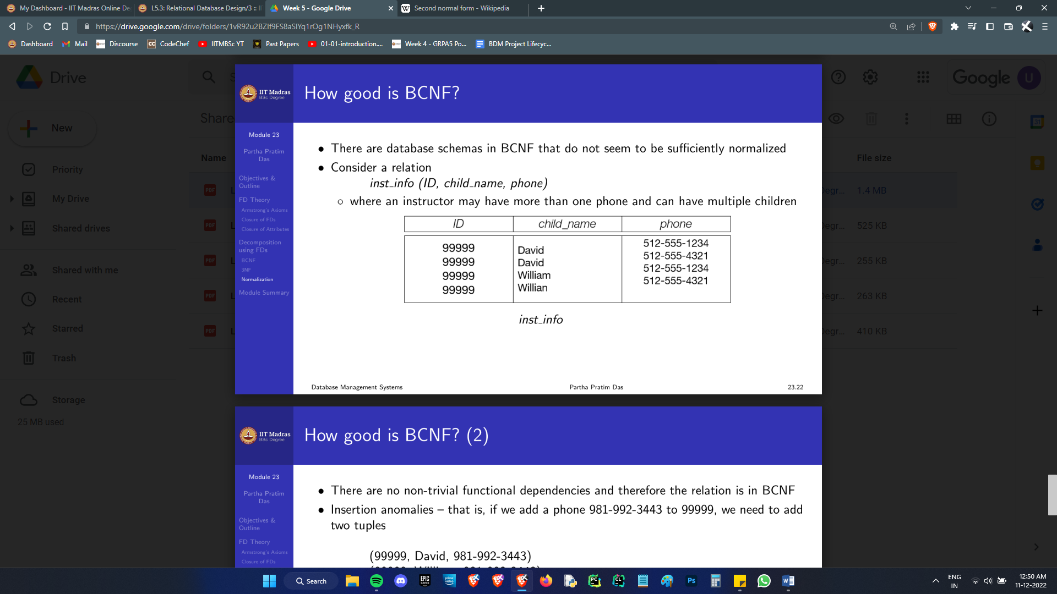That’s obviously crappy design. If the prof adds a new phone number, we need to add an entry for each child. But we do not have any outright functional dependencies that violate the BCNF, so this won’t be caught by that.

What is happening here is simple: ID determines children’s names, and phone numbers. They are multivalued attributes. When we enforced 1NF, it didn’t cause a partial dependency. That’s because it’s impossible to have a “partial” dependency when you’ve a candidate key of size 1. The relation is in BCNF now.

So, we get rid of these hidden, not explicit FDs but actually FDs in the 4th Normal form. Honestly, this would never be an issue if we drew a good ER diagram and kept these multi valued attributes in separate tables. Any normalisation problem can be fixed at the ER level, or more rigorously in the mathematical level. Sometimes one is easier than the other. In my opinion, a healthy dose of common sense is much better than an overdose of math.

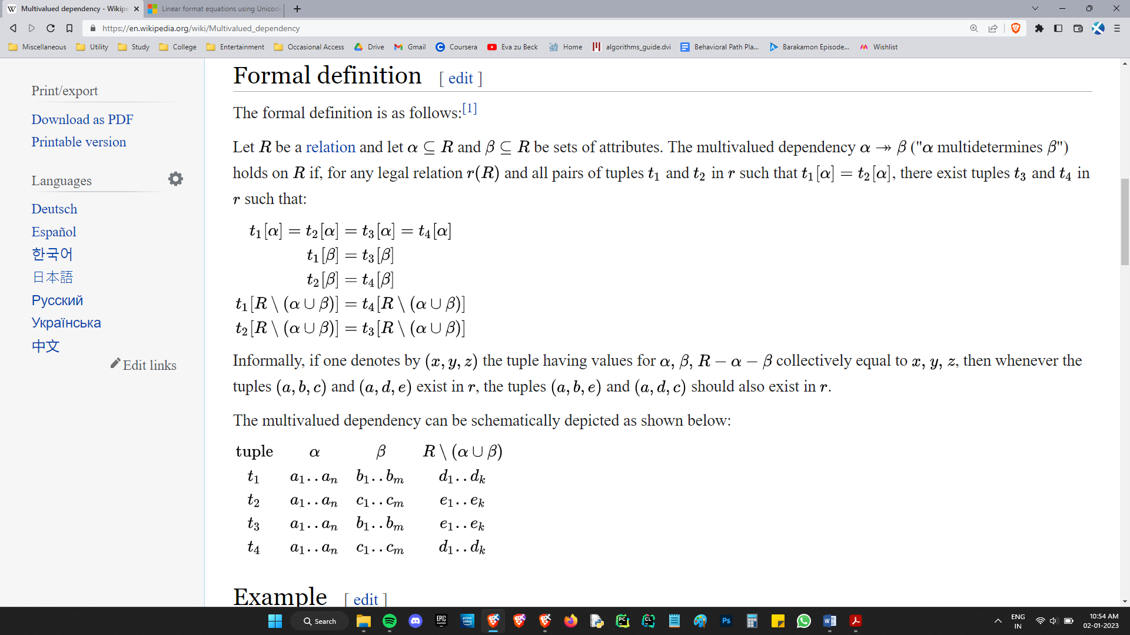Alright, How do we define these “multi-valued-dependencies”? (Henceforth MVDs) (Spoiler alert: This is a pain.)

Imagine a table with an ID attribute, a phone no which has been squished, and a looong series of a lot of attributes after that. When there are 2 different phone nos for the same ID, the entire long row repeats. (When 2 tuples match on α, the key, but have different β, the target, then the rest of the row, R- β will repeat. Further, if there is a second long piece associated with α, then that thing will occur in combination with every β. It’s a Cartesian product’s worth of juggling, basically.)

Sigh. The definition is convoluted, no denying it. The worst part is that Armstrong’s axioms no longer hold for MVDs. We need to make new math. Lol. Hell nah. Thank you, next.

All functional dependencies are actually MVDs; the definition allows it. So, working with MVDs, we can make more general, more comprehensive constraints.

A relation schema R is in 4NF with respect to a set D of MVDs if

∀ MVD ∈ D+ of the form α →→ β, where α ⊆ R and β ⊆ R,

At least one of the following holds:

◦ α →→ β is trivial (that is, β ⊆ α, or α∪β = R)

◦ α is a superkey for R

The definition looks *exactly* like the BCNF definition. D+ is a superset of F+, so things work out. The new feature is that no non trivial MVD is permitted.

If there exists a non trivial α →→ β, just do the same old BCNF breakdown:

Split R into α ∪ β and (R − (β − α))

Oh, right, the definition of trivial changed; We consider full tuple MVDs as trivial. The entire tuple is unique, so if 2 tuples match on α, they will match on β, and therefore satisfy the definition of MVDs.

I can feel a mild headache brewing when I slowly eye the prospect of having to learn MVD math. Fine, I’ll stop whining and add it in another section.

Let me conclude this with a short finishing note:

If we dig more we will find more and more issues, and there are a lot more levels of normalisation to address that. Here they are in all their glory:

* Elementary Key Normal Form (EKNF)
* Essential Tuple Normal Form (ETNF)
* Join Dependencies And Fifth Normal Form (5 NF)
* Sixth Normal Form (6NF)
* Domain/Key Normal Form (DKNF)

People do not bother with anything above 4NF; Hell, it’s typically 3NF or BCNF they stop at. There are 3 reasons for this:

1) We keep making more and more tables to get rid of dependencies, and then when we run queries we need to run natural joins. That’s going to slow down everything *a lot*.

People deliberately ***denormalise*** some schema, simply because it’s faster to have a schema with some dependency. We can live with it. It’s not going to kill you, just take up some extra space. It’s highly impractical to even consider normalising *beyond* 4NF.

2) Most bad schema beyond 4NF are detectable by the radar of common sense. One may make schema with attributes earnings_2004, earnings_2005, earnings_2006 because all accountancy business works within one year. That kind of schema will be full of nulls, having the 2004 attribute null for most of the data, and this makes querying data across years a pain. This is in BCNF.

We don’t need a formal mathematical theory to know that that’s bad design. Just make an attribute called year, and filter based on it whenever it’s needed, and the performance will be an undetectable smidge worse but the design will be better by leaps and bounds.

3) This one, I’m not very sure of, but I can claim with reasonable confidence from what I know. Studying everything till DKNF and all gives you, not mild headaches, but full on migraines.

## MVD math

# Week 7 : App Dev with SQL

This is some proper App dev content.

I don’t really like the way I’m learning application development. I can’t bring myself to care about half the things discussed.

It ought to be a hundred times more hands on. There’s theory, theory, and more theory, and none of it holds any meaning, unless you have the experience to make sure that your brain nails it down, comprehends its weight, and the top left of the screen goes “Your Brain will remember that”

It’s quite a pain to acclimatise to the jargon. It’s quite the journey to gain the confidence to stride and not feel lost.

I’d like to look at this week’s content as an overview of how a website works; End of the day, every website is some code. Where are these pieces of code? Who executes them and when? What language is it in? What does each piece of code do? Does any of this change depending on the application?

Those are mysteries I have always wanted answered.

At the risk of sounding like a broken record, we can view a website’s functionality as compartmentalised into 3 layers: that of the model, view and control.

On our computer,

# Week 8 : Storing and Indexing Databases

### Storage Policy 1: Arrays

Consider the storage of a simple array. How exactly can we take a series of 1s and 0s and make sense out of it, as a sequence of separate entities?

The most natural way to approach this is by giving each entry the exact same amount of space. That way, if we want to access arr[3] we can simply add 3*entry_size to the starting address. The block of size entry_size starting there is the entry we need.

This is exactly how C++ arrays work. The entry_size is determined by the datatype we declare the array to be in.

There are some issues with this approach: What if I wish to store entries of variable size? If we wish to use the same strategy even then, we must force the same size on each entity. The size will need to suit even the largest one, thereby making most entries have a significant amount of padding, wasting a lot of space. Bad Idea.

If we instead just store consecutive blobs of data, there won’t be any easy way to access the nth element of the array. Each entry will have to end with a line that goes “here, I end, and the next begins” That would make access a nightmare. We cannot afford to waste time scanning an entire array of million+ entries to access just one.

There’s a way to walk the middle path, and escape both pitfalls: Just store pointers instead of data in the array. The pointers will always be of a fixed size, so we can very quickly access any entry of the array. When we want the actual data in an entry, we can just follow the pointer into the place where the data is stored, and pull out the required number of bytes. Of course, since the size of the entry is a variable, we must store it along with the pointers in the array.

### Storage Policy 2: Free Lists : Deletion and Insertion

Okay, we have made some progress. There is still much room for improvement, in terms of our storage and management policies. Do we store columns of data, or rows? What happens when we add a column? How to delete a record, or insert one?

Row and Column orientations are both commonly adopted strategies. It depends on that particular database’s architecture. They both have systems in place for the insertion deletion and access of entries. Let’s just deal with row oriented databases since they are somewhat easier to think about. If we have n columns, we’ll just have the first n entries representing the first row with its equal sized pointer-datasize boxes, then the next n give the next row and so on.

Okay, how do we delete a record? A naïve way about this would be shifting every entry into the gap created by the deletion, but that’s just pointless. We just need to label that record as free for future usage. We can fill that space with information that says “I’m empty, look at the next guy for data.”

In order to overwrite this in the future, we need to keep track of all the empty entries. Maintaining a list of empty entries is a valid approach, but we can do one better. In the header, we can store the address of the first empty record, and we can use that very record’s space to point to the next empty record. If we write on this record, we can edit the header to point to the next one. This way, we can store the location of all empty records while cleverly not taking any substantial space.

This is called a “free list”.

### Storage Policy 3: Tables and Schema

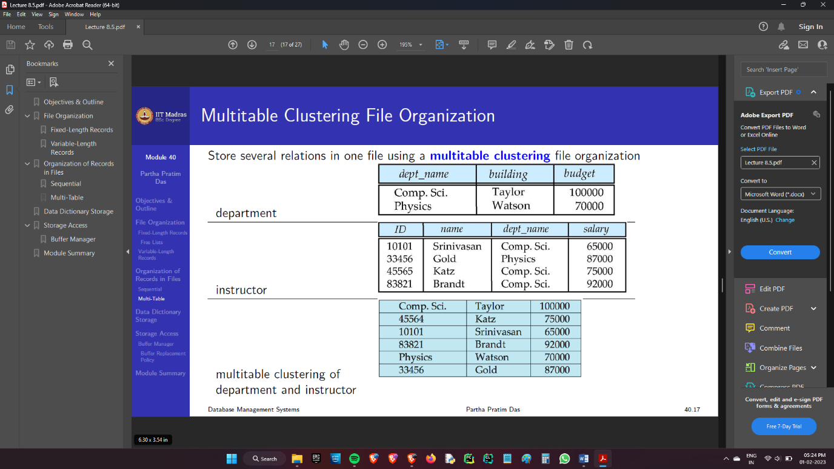Entire relations of records needn’t be stored as such, and multiple tables can be stored together in something called a “multirelational cluster” which basically has an inner join already done for you in some sense:

Although it makes inner joins quicker, accessing just the department table becomes a bit tedious, because we will have some linked list business connecting those entries in this table. On top of this, the 2 tables we merge need not have the same number of attributes, so the record length might vary.

The information about the name, number, size, properties of all relations are all stored separately in their own optimised data structure. It’s called a data dictionary or a System catalog.

That’s it for how we store tables. I know I didn’t go into the details of how exactly it’s done, or into how we delete or insert data, but I don’t think I want to. It’s clever design, no doubt; It’s just that it’s so many levels of abstraction below that I don’t think it helps to know about it, beyond what has already been discussed.

What is much more important, is how we access it. This is something we will keep doing with our every query, so we must know to keep it optimal.

### Storage Policy 4: Hard drive Blocks

The storage on a hard drive is organised into units called blocks. Each block will have a header that points to the data within it, information of how many records it has etc. When I said that records are stored with pointers to data, the pointer actually points to the entry for the record in the block header, so there’s one more jump.

At the lowest level, we go fetch blocks of data from storage and put it in a buffer in our RAM. Since we can only allocate a finite amount of space for this purpose, we optimise the block fetching and swapping. If we don’t have room for a block, we must overwrite one, and before doing so, we must write the block in your RAM into the storage to commit changes.

There is a dedicated buffer manager process that does this in an efficient manner.

This is the access situation at the physical level. What we have discussed is how we can efficiently store and retrieve *some* data. We have not discussed how we are going to organise the arrays containing records of data, at a conceptual level rather than a physical one.

### Access Policy 1: Sorting

If we simply store all the records blindly, then we will need to scan all records to find a match for the simplest query, and a join becomes so absurdly costly to perform, you might as well give up on it.

We must implement some form of retrieval mechanism. The simplest one is simply sorting the records on some attribute, so that we can binary search our way through the database.

Well, that works for exactly one attribute, but can we do better?

Easy solution: maintain a list of tuples of the form (indexed attribute, pointer to the full record) and sort this list with respect to the attribute. Now, a bunch of these can be made, and each one can be sorted according to their attribute, enabling binary search using any attribute.

This actually solves another issue: If we had just sorted that attribute in the table, we would have to load the table into the buffer in order to do a binary search. The table is likely *large*. We will need to make a *ton* of block transfers and overwrites.

The list that indexes one attribute is called an index file. It’s significantly smaller than the actual table, so it can probably fit within a single block. Doing cross block binary search is *real* pain. We like to avoid that as much as possible.

In fact, when your index file stretches across a great many blocks, it’s so bad that people decided things will be faster if we made an index for the index and fit things into one block somehow. The spirit of DBMS is this: you must be able to let the database grow substantially without severely impacting your processing times.

But the index is already a 2 by n table. Any index needs that size. Indexing the index *won’t* cut down the size. So, what if we had an index that can tell us which block to go to? Basically, take one out of x entries from the index table, and by binary searching here, we can locate between which 2 entries the index we want is located. We can then load that block and find the exact index.

If the database grows, the temptation is to enlarge x so that we can fit this secondary “outer” index into one block. But that becomes less and less useful with the growth of the database.

Thus, we just pick a reasonable enough x, and if the outer index grows, we keep making more indices for indices.

By the way, this type of an index, where you store only some of the entries rather than all, and leaving the fine grain pinpointing to another person, is called a sparse index. This is in contrast with the first index we made, where we indexed an entire attribute without leaving anything out; a “dense” index.

We *can* make a sparse index to the table directly, rather than making a spare index *for* a dense index. This works only if your table is already physically sorted according to that attribute.

If a sorted attribute is indexed, the index is called a “primary index” or a “clustering index”. Otherwise, it’s called a “secondary index” or a “non-clustering index”.

I think it’s a terrible idea because a free list deletion and insert policy cannot be used in a physically sorted table.

There are still issues with this indexing system. Any given attribute may have non unique values. In that case, how exactly would you store it in the index? One policy is simply allowing non-unique entries in your index. You can have 5 pointers all for “Ram” stored consecutively. The unavoidable issue here is that you now always need to go to each of those records, and then check left and right before you can confirm that this is the entry you wanted, even if that entry was a unique entry for the attribute.

What’s more efficient than have 5 “Ram” entries is having just one. The solution is to not have pointers directly to the record. Rather, have just one entry on the index even for the repeated value, and have that index point to a list of pointers that point to the all the matching records. That way you atleast lower the size of your dense index. ~~I should’ve just titled this week Pointerception.~~

Naïve developers tend to make indices on a large number of attributes, and they do succeed in obtaining lightning fast access times; Only, now they have to pay a hefty price when they update or delete entries, when you must go to each relevant index and maintain the sorted order. The effort has a chance to be significantly higher in the case of many layers of indices.

Access patterns are paramount in deciding what attributes are indexed; only index attributes that are frequently queried.

Union all

Except all